HOME: 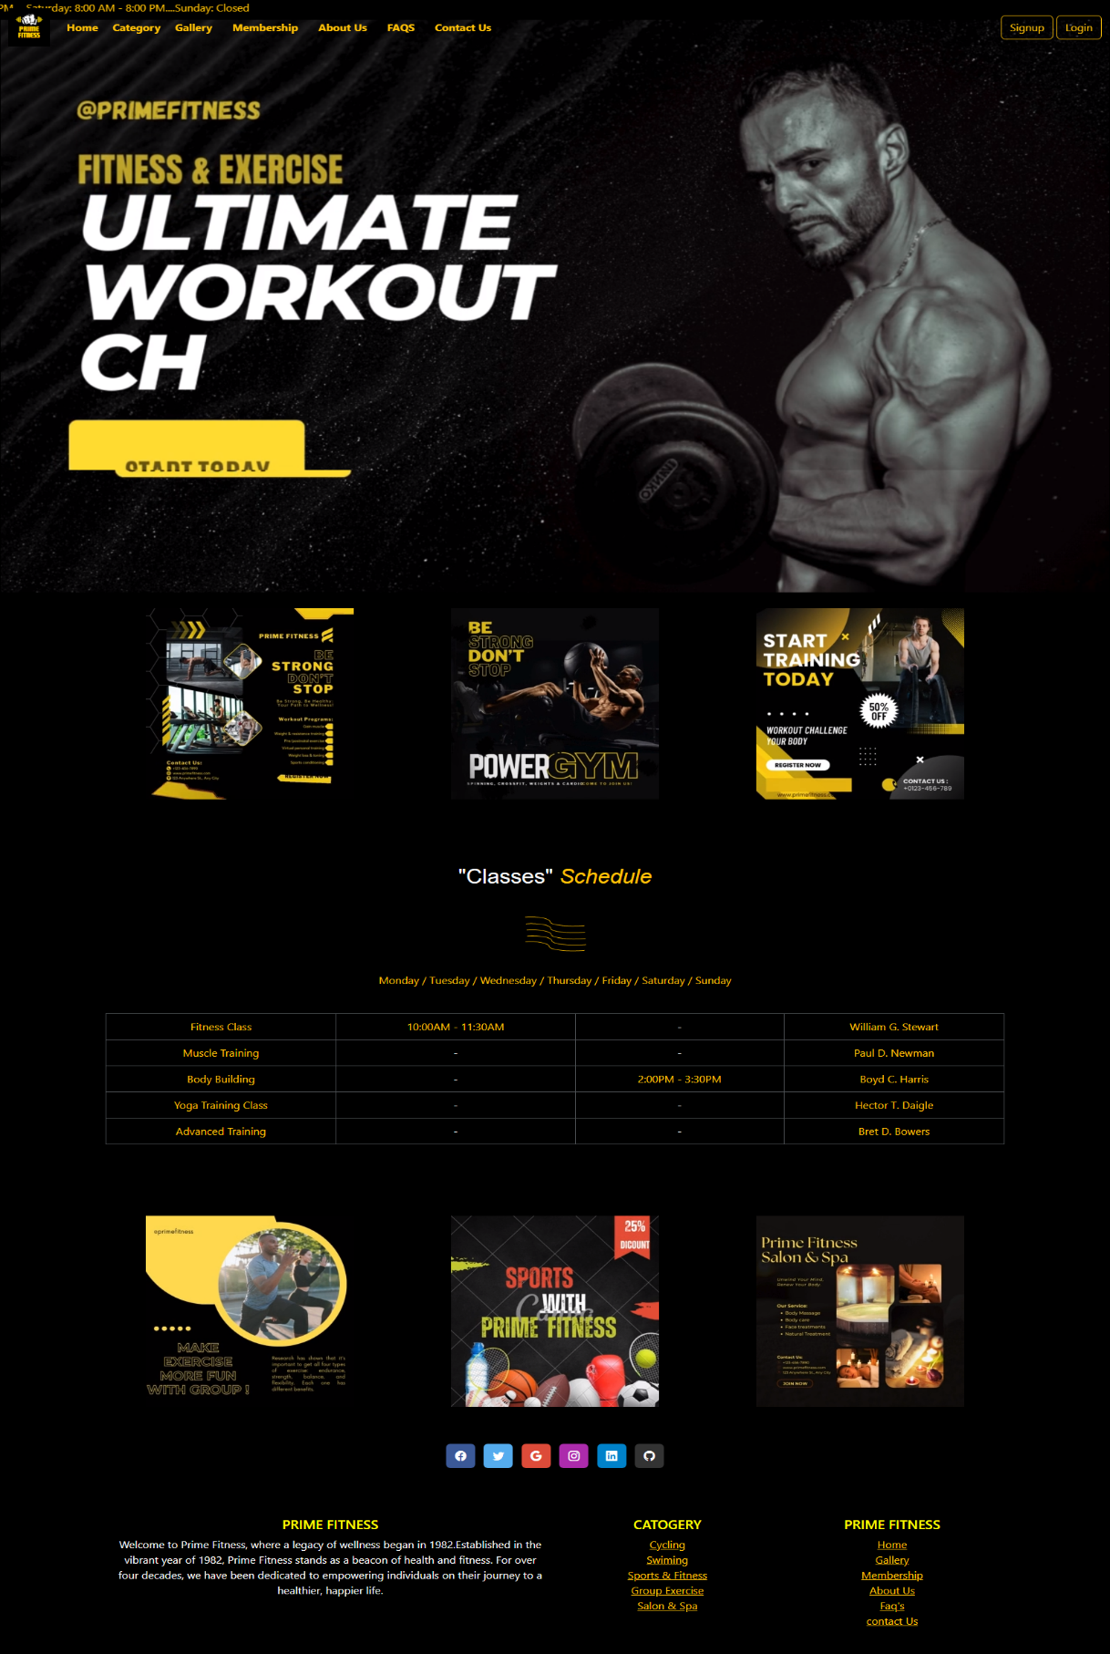

<!DOCTYPE html>

<html lang="en">

<head>

  <meta charset="UTF-8">

  <meta name="viewport" content="width=device-width, initial-scale=1.0">

  <title>Prime Fitness</title>

  <link rel="icon" href="IMAGES/P1.png">

  <!-- CDN start -->

  <link href="https://cdn.jsdelivr.net/npm/bootstrap@5.3.2/dist/css/bootstrap.min.css" rel="stylesheet"

    integrity="sha384-T3c6CoIi6uLrA9TneNEoa7RxnatzjcDSCmG1MXxSR1GAsXEV/Dwwykc2MPK8M2HN" crossorigin="anonymous">

  <script src="https://cdn.jsdelivr.net/npm/bootstrap@5.3.2/dist/js/bootstrap.bundle.min.js"

    integrity="sha384-C6RzsynM9kWDrMNeT87bh95OGNyZPhcTNXj1NW7RuBCsyN/o0jlpcV8Qyq46cDfL"

    crossorigin="anonymous"></script>

  <!-- CDN end -->

  <!-- icon CDN -->

  <link rel="stylesheet" href="https://cdn.jsdelivr.net/npm/bootstrap-icons@1.11.3/font/bootstrap-icons.min.css">

  <!-- Icon ENd -->

  <style>

    /* Additional styling to remove button-like appearance */

    .custom-dropdown {

      display: inline-block;

      position: relative;

      cursor: pointer;

    }

    .dropdown-menu {

      position: absolute;

      top: 100%;

      left: 0;

      z-index: 1000;

      display: none;

      float: left;

      min-width: 10rem;

      padding: .5rem 0;

      margin: .125rem 0 0;

      font-size: 1rem;

      color: #212529;

      text-align: left;

      list-style: none;

      background-color: #fff;

      background-clip: padding-box;

      border: 1px solid rgba(0, 0, 0, .15);

      border-radius: .25rem;

    }

    .custom-dropdown:hover .dropdown-menu {

      display: block;

    }

    .custom-dropdown {

      padding-top: 7.5px;

    }

    li {

      background-color: black;

    }

    .outlined-text {

      color: yellow;

      text-shadow:

        -1px -1px 0 #000,

        1px -1px 0 #000,

        -1px 1px 0 #000,

        1px 1px 0 #000;

    }

    .card {

      background-color: black;

    }

    h2 {

      text-align: center;

      font-family: sans-serif;

    }

    .center {

      display: block;

      margin-left: auto;

      margin-right: auto;

    }

    .days {

      text-align: center;

    }

    td {

      text-align: center;

      text-decoration: solid;

    }

  </style>

</head>

<body class="bg-black">

  <marquee class="text-warning"  behavior="scroll" direction="left">

    Welcome to our website! PRIME FITNESS!!!...Your Path to a Healthier.Monday - Friday: 6:00 AM - 10:00 PM.... Saturday: 8:00 AM - 8:00 PM....Sunday: Closed

</marquee>

  <!-- Nav Start -->

  <nav class="navbar navbar-expand-lg fixed-top ">

    <div class="container-fluid">

      <a class="navbar-brand" href="index.html">

        <img src="IMAGES/P1.png" alt="" height="60px">

      </a>

      <button class="navbar-toggler" type="button" data-bs-toggle="collapse" data-bs-target="#navbarNavAltMarkup"

        aria-controls="navbarNavAltMarkup" aria-expanded="false" aria-label="Toggle navigation">

        <span class="navbar-toggler-icon " style="background-color: #f0ec08;"></span>

      </button>

      <div class="collapse navbar-collapse" id="navbarNavAltMarkup">

        <div class="navbar-nav">

          <a class="nav-link active text-warning" href="index.html"><b>Home</b></a>

          &nbsp;

          &nbsp;

          <div class="custom-dropdown ">

            <span class="text-warning"><b>Category</b></span>

            <ul class="dropdown-menu text-bg-dark">

              <li><a class="dropdown-item text-bg-dark text-warning" href=catogary\cycling.html>Cycling</a></li>

              <li><a class="dropdown-item text-bg-dark text-warning" href="catogary\swim.html">Swiming</a></li>

              <li><a class="dropdown-item text-bg-dark text-warning" href="Sports & Fitness.html">Sports & Fitness</a>

              </li>

              <li><a class="dropdown-item text-bg-dark text-warning" href="catogary\group exercise.html">Group Exercise</a></li>

              <li><a class="dropdown-item text-bg-dark text-warning" href="catogary\salon and spa.html">Salon & Spa</a></li>

            </ul>

          </div>

          &nbsp;

          &nbsp;

          <a class="nav-link active text-warning" href="Gallery/gallery.html"><b>Gallery</b></a>

          &nbsp;

          &nbsp;

          <a class="nav-link active text-warning" href="membership.html"><b>Membership</b></a>

          &nbsp;

          &nbsp;

          <a class="nav-link active text-warning" href="about us/about us.html"><b>About Us</b></a>

          &nbsp;

          &nbsp;

          <a class="nav-link active text-warning" href="faq.html"><b>FAQS</b></a>

          &nbsp;

          &nbsp;

          <a class="nav-link active text-warning" href="contact us .html"><b>Contact Us</b></a>

        </div>

      </div>

      <form class="d-flex" role="search">

        <button type="submit"  class="btn btn-outline-warning" ><a class="text-warning" style="text-decoration: none;" href="Signup.html">Signup</a></button>

        &nbsp;

        <button type="submit"  class="btn btn-outline-warning" ><a class="text-warning" style="text-decoration: none;" href="login.html">Login</a></button>

      </form>

    </div>

  </nav>

  <!-- Nav End -->

  <!-- Carousel Start -->

  <div class="card" style="width: 100%px;">

    <video loop autoplay loop muted loop>

      <source src="video/b7.mp4" type="video/mp4">

    </video>

  </div>

  <!-- Carousel End -->

  <!-- Grid Start -->

  <div class="container text-center">

    <div class="row ">

      <div class="col mt-4 mb-4">

        <video loop autoplay loop muted loop>

          <source src="video/b4.mp4" type="video/mp4">

        </video>

        <br>

      </div>

      <div class="col mt-4 mb-4">

        <video loop autoplay loop muted loop>

          <source src="video/b5.mp4" type="video/mp4" style="height: 200px;">

        </video>

        <br>

      </div>

      <div class="col mt-4 mb-4">

        <video loop autoplay loop muted loop>

          <source src="video/b6.mp4" type="video/mp4">

        </video>

      </div>

    </div>

  </div>

  <br>

  <br>

  <br>

  <!-- Grid End -->

  <!-- table Start -->

  <div class="container">

    <h2 class="text-light">

      "Classes"

      <em class="text-warning">Schedule</em>

    </h2>

    <br>

    <img src="video/b9.PNG" alt="" class="center" height="76px">

    <br>

    <table class="table table-bordered custom-table  table-dark" id="tablebg">

      <p class="days text-warning outlined-text">Monday / Tuesday / Wednesday / Thursday / Friday / Saturday / Sunday

      </p>

      <br>

      <thead>

        <tr>

          <td class="text-warning bg-black">Fitness Class</td>

          <td class="text-warning bg-black">10:00AM - 11:30AM </td>

          <td class="bg-black"> - </td>

          <td class="text-warning bg-black">William G. Stewart</td>

        </tr>

      </thead>

      <tbody>

        <tr>

          <td class="text-warning bg-black">Muscle Training</td>

          <td class="bg-black"> - </td>

          <td class="bg-black"> - </td>

          <td class="text-warning bg-black">Paul D. Newman</td>

        </tr>

        <tr>

          <td class="text-warning bg-black">Body Building</td>

          <td class="bg-black"> - </td>

          <td class="text-warning bg-black">2:00PM - 3:30PM</td>

          <td class="text-warning bg-black">Boyd C. Harris</td>

        </tr>

        <tr>

          <td class="text-warning bg-black">Yoga Training Class </td>

          <td class="bg-black"> - </td>

          <td class="bg-black"> - </td>

          <td class="text-warning bg-black">Hector T. Daigle</td>

        </tr>

        <tr>

          <td class="text-warning bg-black">Advanced Training </td>

          <td class="bg-black"> - </td>

          <td class="bg-black"> - </td>

          <td class="text-warning bg-black">Bret D. Bowers</td>

        </tr>

      </tbody>

    </table>

  </div>

  <br>

  <br>

  <br>

  <!-- table End -->

  <!-- Grid Start -->

  <div class="container text-center">

    <div class="row ">

      <div class="col mt-4 mb-4">

        <video loop autoplay loop muted loop>

          <source src="video/b1.mp4" type="video/mp4">

        </video>

        <br>

      </div>

      <div class="col mt-4 mb-4">

        <video loop autoplay loop muted loop>

          <source src="video/b2.mp4" type="video/mp4" style="height: 200px;">

        </video>

        <br>

      </div>

      <div class="col mt-4 mb-4">

        <video loop autoplay loop muted loop>

          <source src="video/b3.mp4" type="video/mp4">

        </video>

      </div>

    </div>

  </div>

  <!-- Grid End -->

  <!-- footer stART  -->

  <footer class=" text-center" style="background-color: #000;">

    <!-- Grid container -->

    <div class="container p-4 pb-0">

      <!-- Section: Social media -->

      <section class="mb-4 pb-4">

        <!-- Facebook -->

        <a data-mdb-ripple-init class="btn text-white btn-floating m-1" style="background-color: #3b5998;" href="https://www.facebook.com/atmospherefitnesspk/" target="_blank"

          role="button"><i class="bi bi-facebook"></i></a>

        <!-- Twitter -->

        <a data-mdb-ripple-init class="btn text-white btn-floating m-1" style="background-color: #55acee;" href="https://twitter.com/GymBodyFitness_" target="_blank"

          role="button"><i class="bi bi-twitter"></i></a>

        <!-- Google -->

        <a data-mdb-ripple-init class="btn text-white btn-floating m-1" style="background-color: #dd4b39;" href="https://www.google.com/webhp?hl=en&sa=X&ved=0ahUKEwjsofiW5cuEAxUv_bsIHWLMDtoQPAgJ" target="_blank"

          role="button"><i class="bi bi-google"></i></a>

        <!-- Instagram -->

        <a data-mdb-ripple-init class="btn text-white btn-floating m-1" style="background-color: #ac2bac;" href="https://www.instagram.com/primefitnesspakistan/" target="_blank"

          role="button"><i class="bi bi-instagram"></i></a>

        <!-- Linkedin -->

        <a data-mdb-ripple-init class="btn text-white btn-floating m-1" style="background-color: #0082ca;" href="https://www.linkedin.com/login" target="_blank"

          role="button"><i class="bi bi-linkedin"></i></a>

        <!-- Github -->

        <a data-mdb-ripple-init class="btn text-white btn-floating m-1" style="background-color: #333333;" href="https://github.com/login" target="_blank"

          role="button"><i class="bi bi-github"></i></a>

      </section>

      <!-- Section: Social media -->

    </div>

    <!-- Grid container -->

  </footer>

  <!-- second footer -->

  <section class="">

    <!-- Footer -->

    <footer class=" text-center" style="background-color: #000;">

      <!-- Grid container -->

      <div class="container p-4">

        <!--Grid row-->

        <div class="row">

          <!--Grid column-->

          <div class="col-lg-6 col-md-12 mb-4 mb-md-0">

            <h5 class="text-uppercase outlined-text">Prime Fitness</h5>

            <p class="text-light">

              Welcome to Prime Fitness, where a legacy of wellness began in 1982.Established in the vibrant year of

              1982, Prime Fitness stands as a beacon of health and fitness. For over four decades, we have been

              dedicated to empowering individuals on their journey to a healthier, happier life.

            </p>

          </div>

          <!--Grid column-->

          <!--Grid column-->

          <div class="col-lg-3 col-md-6 mb-4 mb-md-0">

            <h5 class="text-uppercase outlined-text">Catogery</h5>

            <ul class="list-unstyled mb-0">

              <li>

                <a href="catogary/cycling.html" class="text-warning">Cycling</a>

              </li>

              <li>

                <a href="catogary/swim.html" class="text-warning">Swiming</a>

              </li>

              <li>

                <a href="Sports & Fitness.html" class="text-warning">Sports & Fitness</a>

              </li>

              <li>

                <a href="catogary/group exercise.html" class="text-warning">Group Exercise</a>

              </li>

              <li>

                <a href="catogary/salon and spa.html" class="text-warning">Salon & Spa</a>

              </li>

            </ul>

          </div>

          <!--Grid column-->

          <!--Grid column-->

          <div class="col-lg-3 col-md-6 mb-4 mb-md-0">

            <h5 class="text-uppercase outlined-text">Prime Fitness</h5>

            <ul class="list-unstyled">

              <li>

                <a href="index.html" class="text-warning">Home</a>

              </li>

              <li>

                <a href="Gallery/gallery.html" class="text-warning">Gallery</a>

              </li>

              <li>

                <a href="membership.html" class="text-warning">Membership </a>

              </li>

              <li>

                <a href="about us/about us.html" class="text-warning">About Us</a>

              </li>

              <li>

                <a href="faq.html" class="text-warning">Faq's</a>

              </li>

              <li>

                <a href="contact us .html" class="text-warning">contact Us</a>

              </li>

            </ul>

          </div>

          <!--Grid column-->

        </div>

        <!--Grid row-->

      </div>

      <!-- Grid container -->

      <!-- Copyright -->

      <!-- <div class="text-center p-3" style="background-color: rgba(0, 0, 0, 0.05);">

        © 2020 Copyright:

        <a class="text-body" href="https://mdbootstrap.com/">MDBootstrap.com</a>

      </div> -->

      <!-- Copyright -->

    </footer>

    <!-- Footer -->

  </section>

  <!-- footer end  -->

</body>

</html>

CATEGORIES:

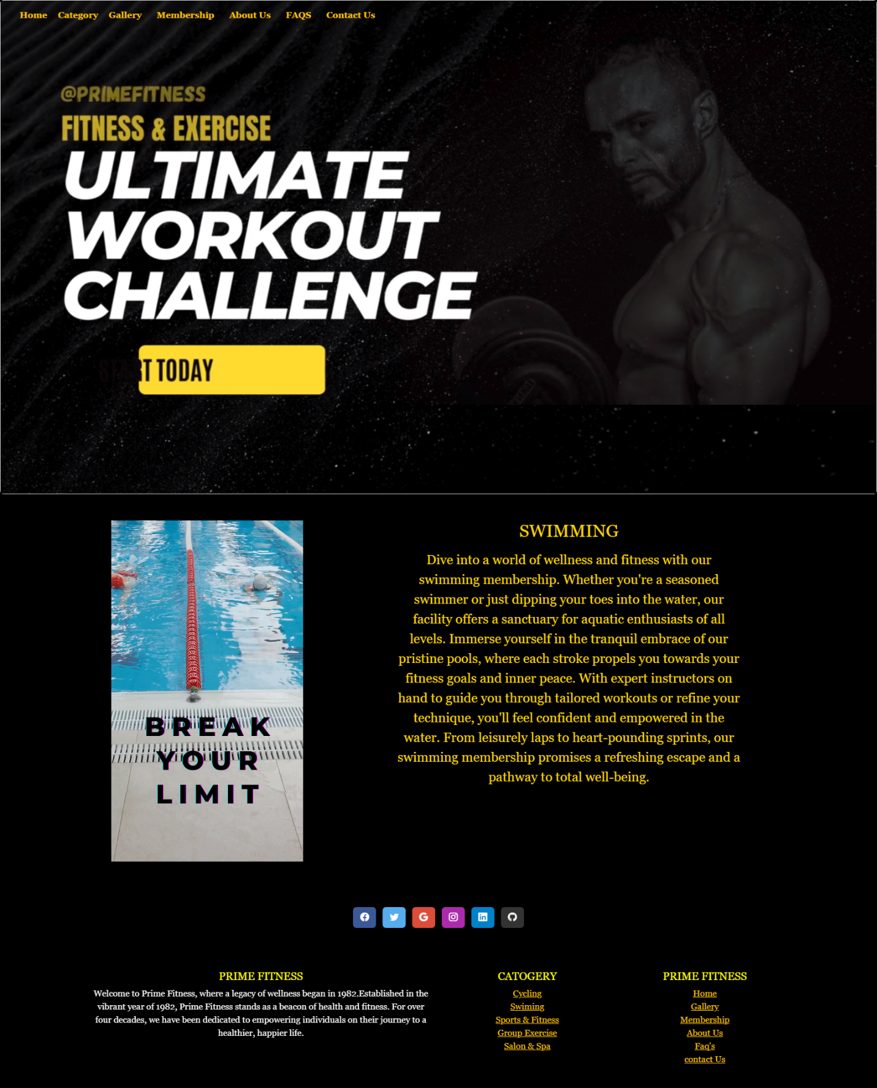

<!DOCTYPE html>

<html lang="en">

<head>

    <meta charset="UTF-8">

    <meta name="viewport" content="width=device-width, initial-scale=1.0">

    <title>SWIMMING</title>

    <link href="https://cdn.jsdelivr.net/npm/bootstrap@5.3.2/dist/css/bootstrap.min.css" rel="stylesheet"

        integrity="sha384-T3c6CoIi6uLrA9TneNEoa7RxnatzjcDSCmG1MXxSR1GAsXEV/Dwwykc2MPK8M2HN" crossorigin="anonymous">

    <script src="https://cdn.jsdelivr.net/npm/bootstrap@5.3.3/dist/js/bootstrap.bundle.min.js"

        integrity="sha384-YvpcrYf0tY3lHB60NNkmXc5s9fDVZLESaAA55NDzOxhy9GkcIdslK1eN7N6jIeHz"

        crossorigin="anonymous"></script>

             <!-- icon CDN -->

  <link rel="stylesheet" href="https://cdn.jsdelivr.net/npm/bootstrap-icons@1.11.3/font/bootstrap-icons.min.css">

  <!-- Icon ENd -->

    <style>

        body {

            background-color: black;

            color: gold;

            font-family: Georgia, 'Times New Roman', Times, serif;

        }

    /* Additional styling to remove button-like appearance */

    .custom-dropdown {

      display: inline-block;

      position: relative;

      cursor: pointer;

    }

    .dropdown-menu {

      position: absolute;

      top: 100%;

      left: 0;

      z-index: 1000;

      display: none;

      float: left;

      min-width: 10rem;

      padding: .5rem 0;

      margin: .125rem 0 0;

      font-size: 1rem;

      color: #212529;

      text-align: left;

      list-style: none;

      background-color: #fff;

      background-clip: padding-box;

      border: 1px solid rgba(0, 0, 0, .15);

      border-radius: .25rem;

    }

    .custom-dropdown:hover .dropdown-menu {

      display: block;

    }

    .custom-dropdown {

      padding-top: 7.5px;

    }

    li {

      background-color: black;

    }

    .outlined-text {

      color: yellow;

      text-shadow:

        -1px -1px 0 #000,

        1px -1px 0 #000,

        -1px 1px 0 #000,

        1px 1px 0 #000;

    }

    </style>

</head>

<body>

  <marquee class="text-warning"  behavior="scroll" direction="left">

    Welcome to our website! PRIME FITNESS!!!...Your Path to a Healthier.Monday - Friday: 6:00 AM - 10:00 PM.... Saturday: 8:00 AM - 8:00 PM....Sunday: Closed

</marquee>

<!-- Nav Start -->

<nav class="navbar navbar-expand-lg fixed-top ">

    <div class="container-fluid">

      <a class="navbar-brand" href="../index.html">

        <img src="IMAGES/P1.png" alt="" height="60px">

      </a>

      <button class="navbar-toggler" type="button" data-bs-toggle="collapse" data-bs-target="#navbarNavAltMarkup"

        aria-controls="navbarNavAltMarkup" aria-expanded="false" aria-label="Toggle navigation">

        <span class="navbar-toggler-icon " style="background-color: #f0ec08;"></span>

      </button>

      <div class="collapse navbar-collapse" id="navbarNavAltMarkup">

        <div class="navbar-nav">

          <a class="nav-link active text-warning" href="../index.html"><b>Home</b></a>

          &nbsp;

          &nbsp;

          <div class="custom-dropdown ">

            <span class="text-warning"><b>Category</b></span>

            <ul class="dropdown-menu text-bg-dark">

              <li><a class="dropdown-item text-bg-dark text-warning" href="cycling.html">Cycling</a></li>

              <li><a class="dropdown-item text-bg-dark text-warning" href="swim.html">Swiming</a></li>

              <li><a class="dropdown-item text-bg-dark text-warning" href="../Sports & Fitness.html">Sports & Fitness</a>

              </li>

              <li><a class="dropdown-item text-bg-dark text-warning" href="group exercise.html">Group Exercise</a></li>

              <li><a class="dropdown-item text-bg-dark text-warning" href="salon and spa.html">Salon & Spa</a></li>

            </ul>

          </div>

          &nbsp;

          &nbsp;

          <a class="nav-link active text-warning" href="../Gallery/gallery.html"><b>Gallery</b></a>

          &nbsp;

          &nbsp;

          <a class="nav-link active text-warning" href="../membership.html"><b>Membership</b></a>

          &nbsp;

          &nbsp;

          <a class="nav-link active text-warning" href="../about us/about us.html"><b>About Us</b></a>

          &nbsp;

          &nbsp;

          <a class="nav-link active text-warning" href="../faq.html"><b>FAQS</b></a>

          &nbsp;

          &nbsp;

          <a class="nav-link active text-warning" href="../contact us .html"><b>Contact Us</b></a>

        </div>

      </div>

    </div>

  </nav>

  <!-- Nav End -->

  <!-- Carousel Start -->

  <div class="card" style="width: 100%px;">

    <video loop autoplay loop muted loop>

      <source src="../video/b7.mp4" type="video/mp4">

    </video>

  </div>

  <!-- Carousel End -->

    <div class="container m-5">

        <div class="row">

            <div class="col-lg-6 col-md-6 col-sm-12 text-center">

                <video loop autoplay loop muted loop width="350px">

                    <source src="images/b2.mp4" type="video/mp4">

                  </video>

            </div>

            <div class="col-lg-6 col-md-6 col-sm-12 d-flex justify-content-center">

                <div class="text-center">

                    <div class=" product_details">

                        <h2 id="name" class="mb-3">SWIMMING</h2>

                    </div>

                    <div class="text-center fs-4 discription write">

                        <p> Dive into a world of wellness and fitness with our swimming membership. Whether you're a seasoned swimmer or

                            just dipping your toes into the water, our facility offers a sanctuary for aquatic enthusiasts of all levels.

                            Immerse yourself in the tranquil embrace of our pristine pools, where each stroke propels you towards your

                            fitness goals and inner peace. With expert instructors on hand to guide you through tailored workouts or refine

                            your technique, you'll feel confident and empowered in the water. From leisurely laps to heart-pounding sprints,

                            our swimming membership promises a refreshing escape and a pathway to total well-being.

                        </p>

                    </div>

                </div>

            </div>

        </div>

    </div>

    <!-- footer stART  -->

  <footer class=" text-center" style="background-color: #000;">

    <!-- Grid container -->

    <div class="container p-4 pb-0">

      <!-- Section: Social media -->

      <section class="mb-4 pb-4">

        <!-- Facebook -->

        <a data-mdb-ripple-init class="btn text-white btn-floating m-1" style="background-color: #3b5998;" href="https://www.facebook.com/atmospherefitnesspk/" target="_blank"

          role="button"><i class="bi bi-facebook"></i></a>

        <!-- Twitter -->

        <a data-mdb-ripple-init class="btn text-white btn-floating m-1" style="background-color: #55acee;" href="https://twitter.com/GymBodyFitness_" target="_blank"

          role="button"><i class="bi bi-twitter"></i></a>

        <!-- Google -->

        <a data-mdb-ripple-init class="btn text-white btn-floating m-1" style="background-color: #dd4b39;" href="https://www.google.com/webhp?hl=en&sa=X&ved=0ahUKEwjsofiW5cuEAxUv_bsIHWLMDtoQPAgJ" target="_blank"

          role="button"><i class="bi bi-google"></i></a>

        <!-- Instagram -->

        <a data-mdb-ripple-init class="btn text-white btn-floating m-1" style="background-color: #ac2bac;" href="https://www.instagram.com/primefitnesspakistan/" target="_blank"

          role="button"><i class="bi bi-instagram"></i></a>

        <!-- Linkedin -->

        <a data-mdb-ripple-init class="btn text-white btn-floating m-1" style="background-color: #0082ca;" href="https://www.linkedin.com/login" target="_blank"

          role="button"><i class="bi bi-linkedin"></i></a>

        <!-- Github -->

        <a data-mdb-ripple-init class="btn text-white btn-floating m-1" style="background-color: #333333;" href="https://github.com/login" target="_blank"

          role="button"><i class="bi bi-github"></i></a>

      </section>

      <!-- Section: Social media -->

    </div>

    <!-- Grid container -->

  </footer>

  <!-- second footer -->

  <section class="">

    <!-- Footer -->

    <footer class=" text-center" style="background-color: #000;">

      <!-- Grid container -->

      <div class="container p-4">

        <!--Grid row-->

        <div class="row">

          <!--Grid column-->

          <div class="col-lg-6 col-md-12 mb-4 mb-md-0">

            <h5 class="text-uppercase outlined-text">Prime Fitness</h5>

            <p class="text-light">

              Welcome to Prime Fitness, where a legacy of wellness began in 1982.Established in the vibrant year of

              1982, Prime Fitness stands as a beacon of health and fitness. For over four decades, we have been

              dedicated to empowering individuals on their journey to a healthier, happier life.

            </p>

          </div>

          <!--Grid column-->

          <!--Grid column-->

          <div class="col-lg-3 col-md-6 mb-4 mb-md-0">

            <h5 class="text-uppercase outlined-text">Catogery</h5>

            <ul class="list-unstyled mb-0">

              <li>

                <a href="../catogary/cycling.html" class="text-warning">Cycling</a>

              </li>

              <li>

                <a href="../catogary/swim.html" class="text-warning">Swiming</a>

              </li>

              <li>

                <a href="../Sports & Fitness.html" class="text-warning">Sports & Fitness</a>

              </li>

              <li>

                <a href="../catogary/group exercise.html " class="text-warning">Group Exercise</a>

              </li>

              <li>

                <a href="../catogary/salon and spa.html" class="text-warning">Salon & Spa</a>

              </li>

            </ul>

          </div>

          <!--Grid column-->

          <!--Grid column-->

          <div class="col-lg-3 col-md-6 mb-4 mb-md-0">

            <h5 class="text-uppercase outlined-text">Prime Fitness</h5>

            <ul class="list-unstyled">

              <li>

                <a href="../index.html" class="text-warning">Home</a>

              </li>

              <li>

                <a href="../Gallery/gallery.html" class="text-warning">Gallery</a>

              </li>

              <li>

                <a href="../membership.html" class="text-warning">Membership </a>

              </li>

              <li>

                <a href="../about us/about us.html " class="text-warning">About Us</a>

              </li>

              <li>

                <a href="../faq.html" class="text-warning">Faq's</a>

              </li>

              <li>

                <a href="../contact us .html" class="text-warning">contact Us</a>

              </li>

            </ul>

          </div>

          <!--Grid column-->

        </div>

        <!--Grid row-->

      </div>

      <!-- Grid container -->

      <!-- Copyright -->

      <!-- <div class="text-center p-3" style="background-color: rgba(0, 0, 0, 0.05);">

        © 2020 Copyright:

        <a class="text-body" href="https://mdbootstrap.com/">MDBootstrap.com</a>

      </div> -->

      <!-- Copyright -->

    </footer>

    <!-- Footer -->

  </section>

  <!-- footer end  -->

</body>

</html>

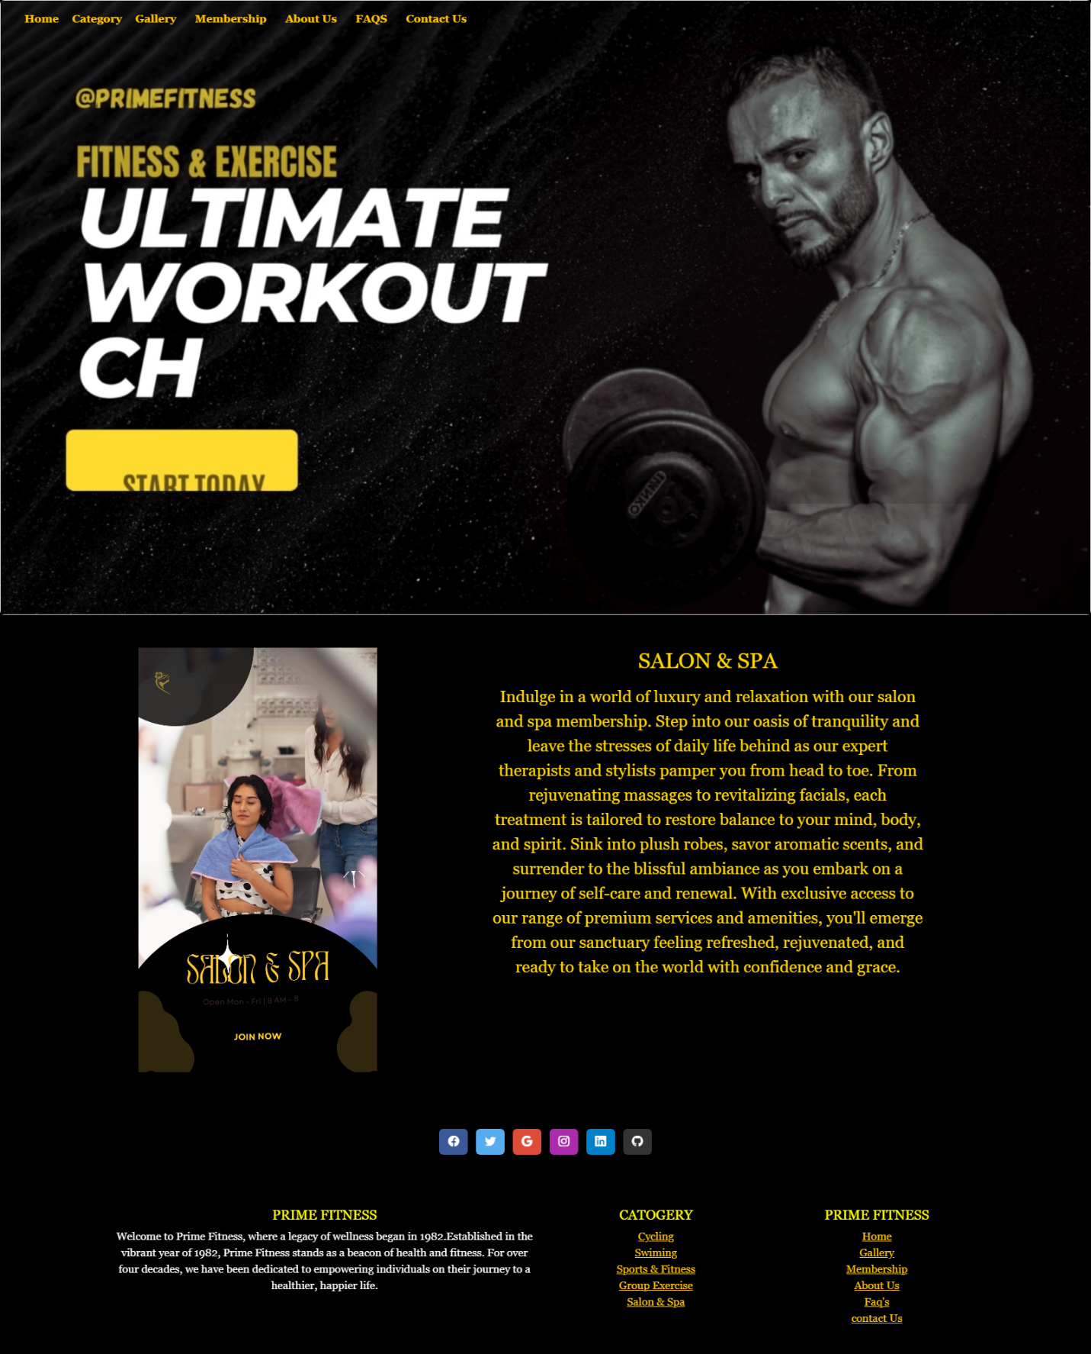

<!DOCTYPE html>

<html lang="en">

<head>

    <meta charset="UTF-8">

    <meta name="viewport" content="width=device-width, initial-scale=1.0">

    <title>SALON & SPA</title>

    <link href="https://cdn.jsdelivr.net/npm/bootstrap@5.3.2/dist/css/bootstrap.min.css" rel="stylesheet"

        integrity="sha384-T3c6CoIi6uLrA9TneNEoa7RxnatzjcDSCmG1MXxSR1GAsXEV/Dwwykc2MPK8M2HN" crossorigin="anonymous">

    <script src="https://cdn.jsdelivr.net/npm/bootstrap@5.3.3/dist/js/bootstrap.bundle.min.js"

        integrity="sha384-YvpcrYf0tY3lHB60NNkmXc5s9fDVZLESaAA55NDzOxhy9GkcIdslK1eN7N6jIeHz"

        crossorigin="anonymous"></script>

             <!-- icon CDN -->

  <link rel="stylesheet" href="https://cdn.jsdelivr.net/npm/bootstrap-icons@1.11.3/font/bootstrap-icons.min.css">

  <!-- Icon ENd -->

    <style>

        body {

            background-color: black;

            color: gold;

            font-family: Georgia, 'Times New Roman', Times, serif;

        }

    /* Additional styling to remove button-like appearance */

    .custom-dropdown {

      display: inline-block;

      position: relative;

      cursor: pointer;

    }

    .dropdown-menu {

      position: absolute;

      top: 100%;

      left: 0;

      z-index: 1000;

      display: none;

      float: left;

      min-width: 10rem;

      padding: .5rem 0;

      margin: .125rem 0 0;

      font-size: 1rem;

      color: #212529;

      text-align: left;

      list-style: none;

      background-color: #fff;

      background-clip: padding-box;

      border: 1px solid rgba(0, 0, 0, .15);

      border-radius: .25rem;

    }

    .custom-dropdown:hover .dropdown-menu {

      display: block;

    }

    .custom-dropdown {

      padding-top: 7.5px;

    }

    li {

      background-color: black;

    }

    .outlined-text {

      color: yellow;

      text-shadow:

        -1px -1px 0 #000,

        1px -1px 0 #000,

        -1px 1px 0 #000,

        1px 1px 0 #000;

    }

    </style>

</head>

<body>

  <marquee class="text-warning"  behavior="scroll" direction="left">

    Welcome to our website! PRIME FITNESS!!!...Your Path to a Healthier.Monday - Friday: 6:00 AM - 10:00 PM.... Saturday: 8:00 AM - 8:00 PM....Sunday: Closed

</marquee>

    <!-- Nav Start -->

    <nav class="navbar navbar-expand-lg fixed-top ">

        <div class="container-fluid">

          <a class="navbar-brand" href="../index.html">

            <img src="IMAGES/P1.png" alt="" height="60px">

          </a>

          <button class="navbar-toggler" type="button" data-bs-toggle="collapse" data-bs-target="#navbarNavAltMarkup"

            aria-controls="navbarNavAltMarkup" aria-expanded="false" aria-label="Toggle navigation">

            <span class="navbar-toggler-icon " style="background-color: #f0ec08;"></span>

          </button>

          <div class="collapse navbar-collapse" id="navbarNavAltMarkup">

            <div class="navbar-nav">

              <a class="nav-link active text-warning" href="../index.html"><b>Home</b></a>

              &nbsp;

              &nbsp;

              <div class="custom-dropdown ">

                <span class="text-warning"><b>Category</b></span>

                <ul class="dropdown-menu text-bg-dark">

                  <li><a class="dropdown-item text-bg-dark text-warning" href="cycling.html">Cycling</a></li>

                  <li><a class="dropdown-item text-bg-dark text-warning" href="swim.html">Swiming</a></li>

                  <li><a class="dropdown-item text-bg-dark text-warning" href="../Sports & Fitness.html">Sports & Fitness</a>

                  </li>

                  <li><a class="dropdown-item text-bg-dark text-warning" href="group exercise.html">Group Exercise</a></li>

                  <li><a class="dropdown-item text-bg-dark text-warning" href="salon and spa.html">Salon & Spa</a></li>

                </ul>

              </div>

              &nbsp;

              &nbsp;

              <a class="nav-link active text-warning" href="../Gallery/gallery.html"><b>Gallery</b></a>

              &nbsp;

              &nbsp;

              <a class="nav-link active text-warning" href="../membership.html"><b>Membership</b></a>

              &nbsp;

              &nbsp;

              <a class="nav-link active text-warning" href="../about us/about us.html"><b>About Us</b></a>

              &nbsp;

              &nbsp;

              <a class="nav-link active text-warning" href="../faq.html"><b>FAQS</b></a>

              &nbsp;

              &nbsp;

              <a class="nav-link active text-warning" href="../contact us .html"><b>Contact Us</b></a>

            </div>

          </div>

        </div>

      </nav>

      <!-- Nav End -->

  <!-- Carousel Start -->

  <div class="card" style="width: 100%px;">

    <video loop autoplay loop muted loop>

      <source src="../video/b7.mp4" type="video/mp4">

    </video>

  </div>

  <!-- Carousel End -->

    <div class="container m-5">

        <div class="row">

            <div class="col-lg-6 col-md-6 col-sm-12 text-center">

              <video loop autoplay loop muted loop width="350px">

                <source src="images/b4.mp4" type="video/mp4">

              </video>

            </div>

            <div class="col-lg-6 col-md-6 col-sm-12 d-flex justify-content-center">

                <div class="text-center">

                    <div class=" product_details">

                        <h2 id="name" class="mb-3">SALON & SPA</h2>

                    </div>

                    <div class="text-center fs-4 discription write">

                        <p>Indulge in a world of luxury and relaxation with our salon and spa membership. Step into our oasis of

                            tranquility and leave the stresses of daily life behind as our expert therapists and stylists pamper you from

                            head to toe. From rejuvenating massages to revitalizing facials, each treatment is tailored to restore balance

                            to your mind, body, and spirit. Sink into plush robes, savor aromatic scents, and surrender to the blissful

                            ambiance as you embark on a journey of self-care and renewal. With exclusive access to our range of premium

                            services and amenities, you'll emerge from our sanctuary feeling refreshed, rejuvenated, and ready to take on

                            the world with confidence and grace.

                        </p>

                    </div>

                </div>

            </div>

        </div>

    </div>

     <!-- footer stART  -->

  <footer class=" text-center" style="background-color: #000;">

    <!-- Grid container -->

    <div class="container p-4 pb-0">

      <!-- Section: Social media -->

      <section class="mb-4 pb-4">

        <!-- Facebook -->

        <a data-mdb-ripple-init class="btn text-white btn-floating m-1" style="background-color: #3b5998;" href="https://www.facebook.com/atmospherefitnesspk/" target="_blank"

          role="button"><i class="bi bi-facebook"></i></a>

        <!-- Twitter -->

        <a data-mdb-ripple-init class="btn text-white btn-floating m-1" style="background-color: #55acee;" href="https://twitter.com/GymBodyFitness_" target="_blank"

          role="button"><i class="bi bi-twitter"></i></a>

        <!-- Google -->

        <a data-mdb-ripple-init class="btn text-white btn-floating m-1" style="background-color: #dd4b39;" href="https://www.google.com/webhp?hl=en&sa=X&ved=0ahUKEwjsofiW5cuEAxUv_bsIHWLMDtoQPAgJ" target="_blank"

          role="button"><i class="bi bi-google"></i></a>

        <!-- Instagram -->

        <a data-mdb-ripple-init class="btn text-white btn-floating m-1" style="background-color: #ac2bac;" href="https://www.instagram.com/primefitnesspakistan/" target="_blank"

          role="button"><i class="bi bi-instagram"></i></a>

        <!-- Linkedin -->

        <a data-mdb-ripple-init class="btn text-white btn-floating m-1" style="background-color: #0082ca;" href="https://www.linkedin.com/login" target="_blank"

          role="button"><i class="bi bi-linkedin"></i></a>

        <!-- Github -->

        <a data-mdb-ripple-init class="btn text-white btn-floating m-1" style="background-color: #333333;" href="https://github.com/login" target="_blank"

          role="button"><i class="bi bi-github"></i></a>

      </section>

      <!-- Section: Social media -->

    </div>

    <!-- Grid container -->

  </footer>

  <!-- second footer -->

  <section class="">

    <!-- Footer -->

    <footer class=" text-center" style="background-color: #000;">

      <!-- Grid container -->

      <div class="container p-4">

        <!--Grid row-->

        <div class="row">

          <!--Grid column-->

          <div class="col-lg-6 col-md-12 mb-4 mb-md-0">

            <h5 class="text-uppercase outlined-text">Prime Fitness</h5>

            <p class="text-light">

              Welcome to Prime Fitness, where a legacy of wellness began in 1982.Established in the vibrant year of

              1982, Prime Fitness stands as a beacon of health and fitness. For over four decades, we have been

              dedicated to empowering individuals on their journey to a healthier, happier life.

            </p>

          </div>

          <!--Grid column-->

          <!--Grid column-->

          <div class="col-lg-3 col-md-6 mb-4 mb-md-0">

            <h5 class="text-uppercase outlined-text">Catogery</h5>

            <ul class="list-unstyled mb-0">

              <li>

                <a href="../catogary/cycling.html" class="text-warning">Cycling</a>

              </li>

              <li>

                <a href="../catogary/swim.html" class="text-warning">Swiming</a>

              </li>

              <li>

                <a href="../Sports & Fitness.html & Fitness.html" class="text-warning">Sports & Fitness</a>

              </li>

              <li>

                <a href="../catogary/group exercise.html " class="text-warning">Group Exercise</a>

              </li>

              <li>

                <a href="../catogary/salon and spa.html" class="text-warning">Salon & Spa</a>

              </li>

            </ul>

          </div>

          <!--Grid column-->

          <!--Grid column-->

          <div class="col-lg-3 col-md-6 mb-4 mb-md-0">

            <h5 class="text-uppercase outlined-text">Prime Fitness</h5>

            <ul class="list-unstyled">

              <li>

                <a href="../index.html" class="text-warning">Home</a>

              </li>

              <li>

                <a href="../Gallery/gallery.html" class="text-warning">Gallery</a>

              </li>

              <li>

                <a href="../membership.html" class="text-warning">Membership </a>

              </li>

              <li>

                <a href="../about us/about us.html " class="text-warning">About Us</a>

              </li>

              <li>

                <a href="../faq.html" class="text-warning">Faq's</a>

              </li>

              <li>

                <a href="../contact us .html" class="text-warning">contact Us</a>

              </li>

            </ul>

          </div>

          <!--Grid column-->

        </div>

        <!--Grid row-->

      </div>

      <!-- Grid container -->

      <!-- Copyright -->

      <!-- <div class="text-center p-3" style="background-color: rgba(0, 0, 0, 0.05);">

        © 2020 Copyright:

        <a class="text-body" href="https://mdbootstrap.com/">MDBootstrap.com</a>

      </div> -->

      <!-- Copyright -->

    </footer>

    <!-- Footer -->

  </section>

  <!-- footer end  -->

</body>

</html>

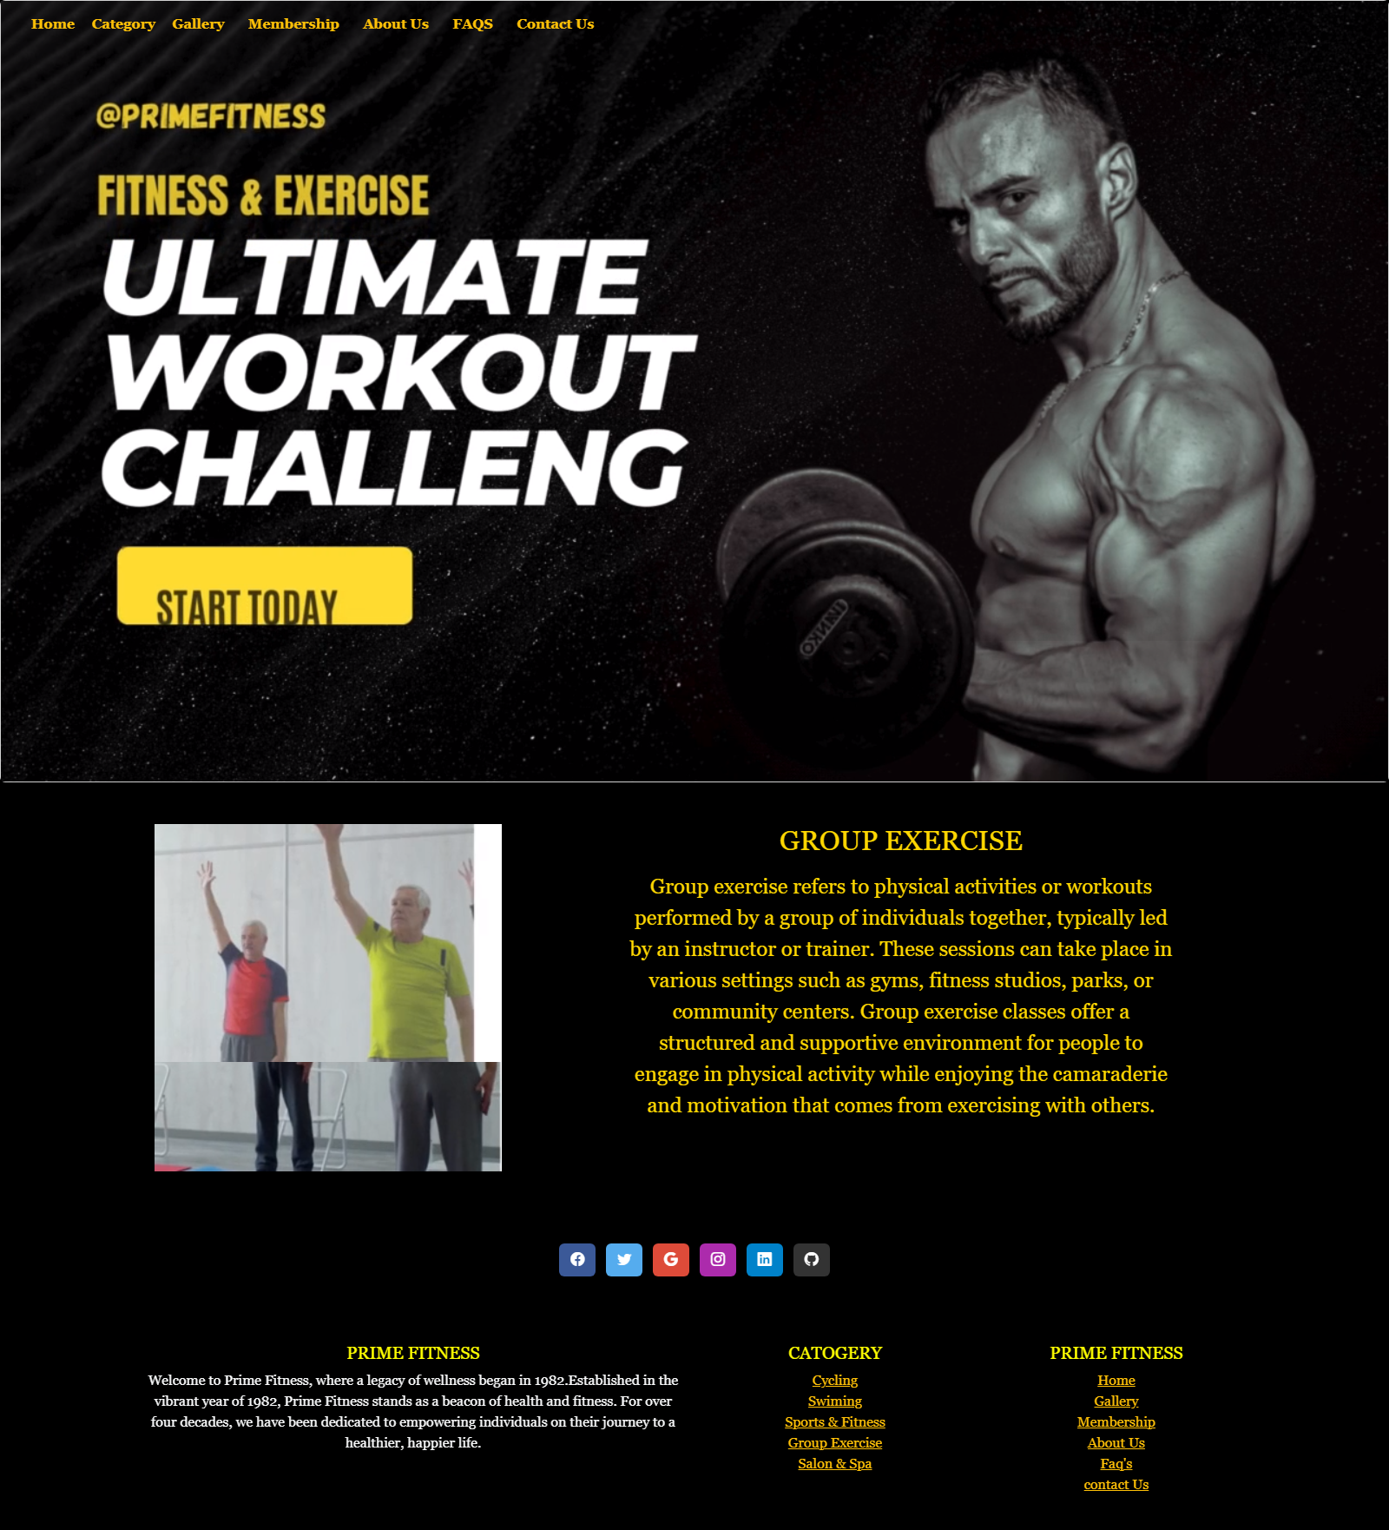

<!DOCTYPE html>

<html lang="en">

<head>

    <meta charset="UTF-8">

    <meta name="viewport" content="width=device-width, initial-scale=1.0">

    <title>GROUP EXERCISE</title>

    <link href="https://cdn.jsdelivr.net/npm/bootstrap@5.3.2/dist/css/bootstrap.min.css" rel="stylesheet"

        integrity="sha384-T3c6CoIi6uLrA9TneNEoa7RxnatzjcDSCmG1MXxSR1GAsXEV/Dwwykc2MPK8M2HN" crossorigin="anonymous">

    <script src="https://cdn.jsdelivr.net/npm/bootstrap@5.3.3/dist/js/bootstrap.bundle.min.js"

        integrity="sha384-YvpcrYf0tY3lHB60NNkmXc5s9fDVZLESaAA55NDzOxhy9GkcIdslK1eN7N6jIeHz"

        crossorigin="anonymous"></script>

             <!-- icon CDN -->

  <link rel="stylesheet" href="https://cdn.jsdelivr.net/npm/bootstrap-icons@1.11.3/font/bootstrap-icons.min.css">

  <!-- Icon ENd -->

    <style>

        body {

            background-color: black;

            color: gold;

            font-family: Georgia, 'Times New Roman', Times, serif;

        }

    /* Additional styling to remove button-like appearance */

    .custom-dropdown {

      display: inline-block;

      position: relative;

      cursor: pointer;

    }

    .dropdown-menu {

      position: absolute;

      top: 100%;

      left: 0;

      z-index: 1000;

      display: none;

      float: left;

      min-width: 10rem;

      padding: .5rem 0;

      margin: .125rem 0 0;

      font-size: 1rem;

      color: #212529;

      text-align: left;

      list-style: none;

      background-color: #fff;

      background-clip: padding-box;

      border: 1px solid rgba(0, 0, 0, .15);

      border-radius: .25rem;

    }

    .custom-dropdown:hover .dropdown-menu {

      display: block;

    }

    .custom-dropdown {

      padding-top: 7.5px;

    }

    li {

      background-color: black;

    }

    .outlined-text {

      color: yellow;

      text-shadow:

        -1px -1px 0 #000,

        1px -1px 0 #000,

        -1px 1px 0 #000,

        1px 1px 0 #000;

    }

    </style>

</head>

<body>

  <marquee class="text-warning"  behavior="scroll" direction="left">

    Welcome to our website! PRIME FITNESS!!!...Your Path to a Healthier.Monday - Friday: 6:00 AM - 10:00 PM.... Saturday: 8:00 AM - 8:00 PM....Sunday: Closed

</marquee>

   <!-- Nav Start -->

   <nav class="navbar navbar-expand-lg fixed-top ">

    <div class="container-fluid">

      <a class="navbar-brand" href="../index.html">

        <img src="IMAGES/P1.png" alt="" height="60px">

      </a>

      <button class="navbar-toggler" type="button" data-bs-toggle="collapse" data-bs-target="#navbarNavAltMarkup"

        aria-controls="navbarNavAltMarkup" aria-expanded="false" aria-label="Toggle navigation">

        <span class="navbar-toggler-icon " style="background-color: #f0ec08;"></span>

      </button>

      <div class="collapse navbar-collapse" id="navbarNavAltMarkup">

        <div class="navbar-nav">

          <a class="nav-link active text-warning" href="../index.html"><b>Home</b></a>

          &nbsp;

          &nbsp;

          <div class="custom-dropdown ">

            <span class="text-warning"><b>Category</b></span>

            <ul class="dropdown-menu text-bg-dark">

              <li><a class="dropdown-item text-bg-dark text-warning" href="cycling.html">Cycling</a></li>

              <li><a class="dropdown-item text-bg-dark text-warning" href="swim.html">Swiming</a></li>

              <li><a class="dropdown-item text-bg-dark text-warning" href="../Sports & Fitness.html">Sports & Fitness</a>

              </li>

              <li><a class="dropdown-item text-bg-dark text-warning" href="group exercise.html">Group Exercise</a></li>

              <li><a class="dropdown-item text-bg-dark text-warning" href="salon and spa.html">Salon & Spa</a></li>

            </ul>

          </div>

          &nbsp;

          &nbsp;

          <a class="nav-link active text-warning" href="../Gallery/gallery.html"><b>Gallery</b></a>

          &nbsp;

          &nbsp;

          <a class="nav-link active text-warning" href="../membership.html"><b>Membership</b></a>

          &nbsp;

          &nbsp;

          <a class="nav-link active text-warning" href="../about us/about us.html"><b>About Us</b></a>

          &nbsp;

          &nbsp;

          <a class="nav-link active text-warning" href="../faq.html"><b>FAQS</b></a>

          &nbsp;

          &nbsp;

          <a class="nav-link active text-warning" href="#../contact us .html"><b>Contact Us</b></a>

        </div>

      </div>

    </div>

  </nav>

  <!-- Nav End -->

  <!-- Carousel Start -->

  <div class="card" style="width: 100%px;">

    <video loop autoplay loop muted loop>

      <source src="../video/b7.mp4" type="video/mp4">

    </video>

  </div>

  <!-- Carousel End -->

    <div class="container m-5">

        <div class="row">

            <div class="col-lg-6 col-md-6 col-sm-12 text-center">

                <video loop autoplay loop muted loop width="400px">

                    <source src="images/b3.mp4" type="video/mp4">

                  </video>

            </div>

            <div class="col-lg-6 col-md-6 col-sm-12 d-flex justify-content-center">

                <div class="text-center">

                    <div class=" product_details">

                        <h2 id="name" class="mb-3">GROUP EXERCISE</h2>

                    </div>

                    <div class="text-center fs-4 discription write">

                        <p>

                            Group exercise refers to physical activities or workouts performed by a group of individuals together, typically led by an instructor or trainer. These sessions can take place in various settings such as gyms, fitness studios, parks, or community centers. Group exercise classes offer a structured and supportive environment for people to engage in physical activity while enjoying the camaraderie and motivation that comes from exercising with others.

                        </p>

                    </div>

                </div>

            </div>

        </div>

    </div>

     <!-- footer stART  -->

  <footer class=" text-center" style="background-color: #000;">

    <!-- Grid container -->

    <div class="container p-4 pb-0">

      <!-- Section: Social media -->

      <section class="mb-4 pb-4">

        <!-- Facebook -->

        <a data-mdb-ripple-init class="btn text-white btn-floating m-1" style="background-color: #3b5998;" href="https://www.facebook.com/atmospherefitnesspk/" target="_blank"

          role="button"><i class="bi bi-facebook"></i></a>

        <!-- Twitter -->

        <a data-mdb-ripple-init class="btn text-white btn-floating m-1" style="background-color: #55acee;" href="https://twitter.com/GymBodyFitness_" target="_blank"

          role="button"><i class="bi bi-twitter"></i></a>

        <!-- Google -->

        <a data-mdb-ripple-init class="btn text-white btn-floating m-1" style="background-color: #dd4b39;" href="https://www.google.com/webhp?hl=en&sa=X&ved=0ahUKEwjsofiW5cuEAxUv_bsIHWLMDtoQPAgJ" target="_blank"

          role="button"><i class="bi bi-google"></i></a>

        <!-- Instagram -->

        <a data-mdb-ripple-init class="btn text-white btn-floating m-1" style="background-color: #ac2bac;" href="https://www.instagram.com/primefitnesspakistan/" target="_blank"

          role="button"><i class="bi bi-instagram"></i></a>

        <!-- Linkedin -->

        <a data-mdb-ripple-init class="btn text-white btn-floating m-1" style="background-color: #0082ca;" href="https://www.linkedin.com/login" target="_blank"

          role="button"><i class="bi bi-linkedin"></i></a>

        <!-- Github -->

        <a data-mdb-ripple-init class="btn text-white btn-floating m-1" style="background-color: #333333;" href="https://github.com/login" target="_blank"

          role="button"><i class="bi bi-github"></i></a>

      </section>

      <!-- Section: Social media -->

    </div>

    <!-- Grid container -->

  </footer>

  <!-- second footer -->

  <section class="">

    <!-- Footer -->

    <footer class=" text-center" style="background-color: #000;">

      <!-- Grid container -->

      <div class="container p-4">

        <!--Grid row-->

        <div class="row">

          <!--Grid column-->

          <div class="col-lg-6 col-md-12 mb-4 mb-md-0">

            <h5 class="text-uppercase outlined-text">Prime Fitness</h5>

            <p class="text-light">

              Welcome to Prime Fitness, where a legacy of wellness began in 1982.Established in the vibrant year of

              1982, Prime Fitness stands as a beacon of health and fitness. For over four decades, we have been

              dedicated to empowering individuals on their journey to a healthier, happier life.

            </p>

          </div>

          <!--Grid column-->

          <!--Grid column-->

          <div class="col-lg-3 col-md-6 mb-4 mb-md-0">

            <h5 class="text-uppercase outlined-text">Catogery</h5>

            <ul class="list-unstyled mb-0">

              <li>

                <a href="../catogary/cycling.html" class="text-warning">Cycling</a>

              </li>

              <li>

                <a href="../catogary/swim.html" class="text-warning">Swiming</a>

              </li>

              <li>

                <a href="../Sports & Fitness.html & Fitness.html" class="text-warning">Sports & Fitness</a>

              </li>

              <li>

                <a href="../catogary/group exercise.html " class="text-warning">Group Exercise</a>

              </li>

              <li>

                <a href="../catogary/salon and spa.html" class="text-warning">Salon & Spa</a>

              </li>

            </ul>

          </div>

          <!--Grid column-->

          <!--Grid column-->

          <div class="col-lg-3 col-md-6 mb-4 mb-md-0">

            <h5 class="text-uppercase outlined-text">Prime Fitness</h5>

            <ul class="list-unstyled">

              <li>

                <a href="../index.html" class="text-warning">Home</a>

              </li>

              <li>

                <a href="../Gallery/gallery.html" class="text-warning">Gallery</a>

              </li>

              <li>

                <a href="../membership.html" class="text-warning">Membership </a>

              </li>

              <li>

                <a href="../about us/about us.html " class="text-warning">About Us</a>

              </li>

              <li>

                <a href="../faq.html" class="text-warning">Faq's</a>

              </li>

              <li>

                <a href="../contact us .html" class="text-warning">contact Us</a>

              </li>

            </ul>

          </div>

          <!--Grid column-->

        </div>

        <!--Grid row-->

      </div>

      <!-- Grid container -->

      <!-- Copyright -->

      <!-- <div class="text-center p-3" style="background-color: rgba(0, 0, 0, 0.05);">

        © 2020 Copyright:

        <a class="text-body" href="https://mdbootstrap.com/">MDBootstrap.com</a>

      </div> -->

      <!-- Copyright -->

    </footer>

    <!-- Footer -->

  </section>

  <!-- footer end  -->

</body>

</html>

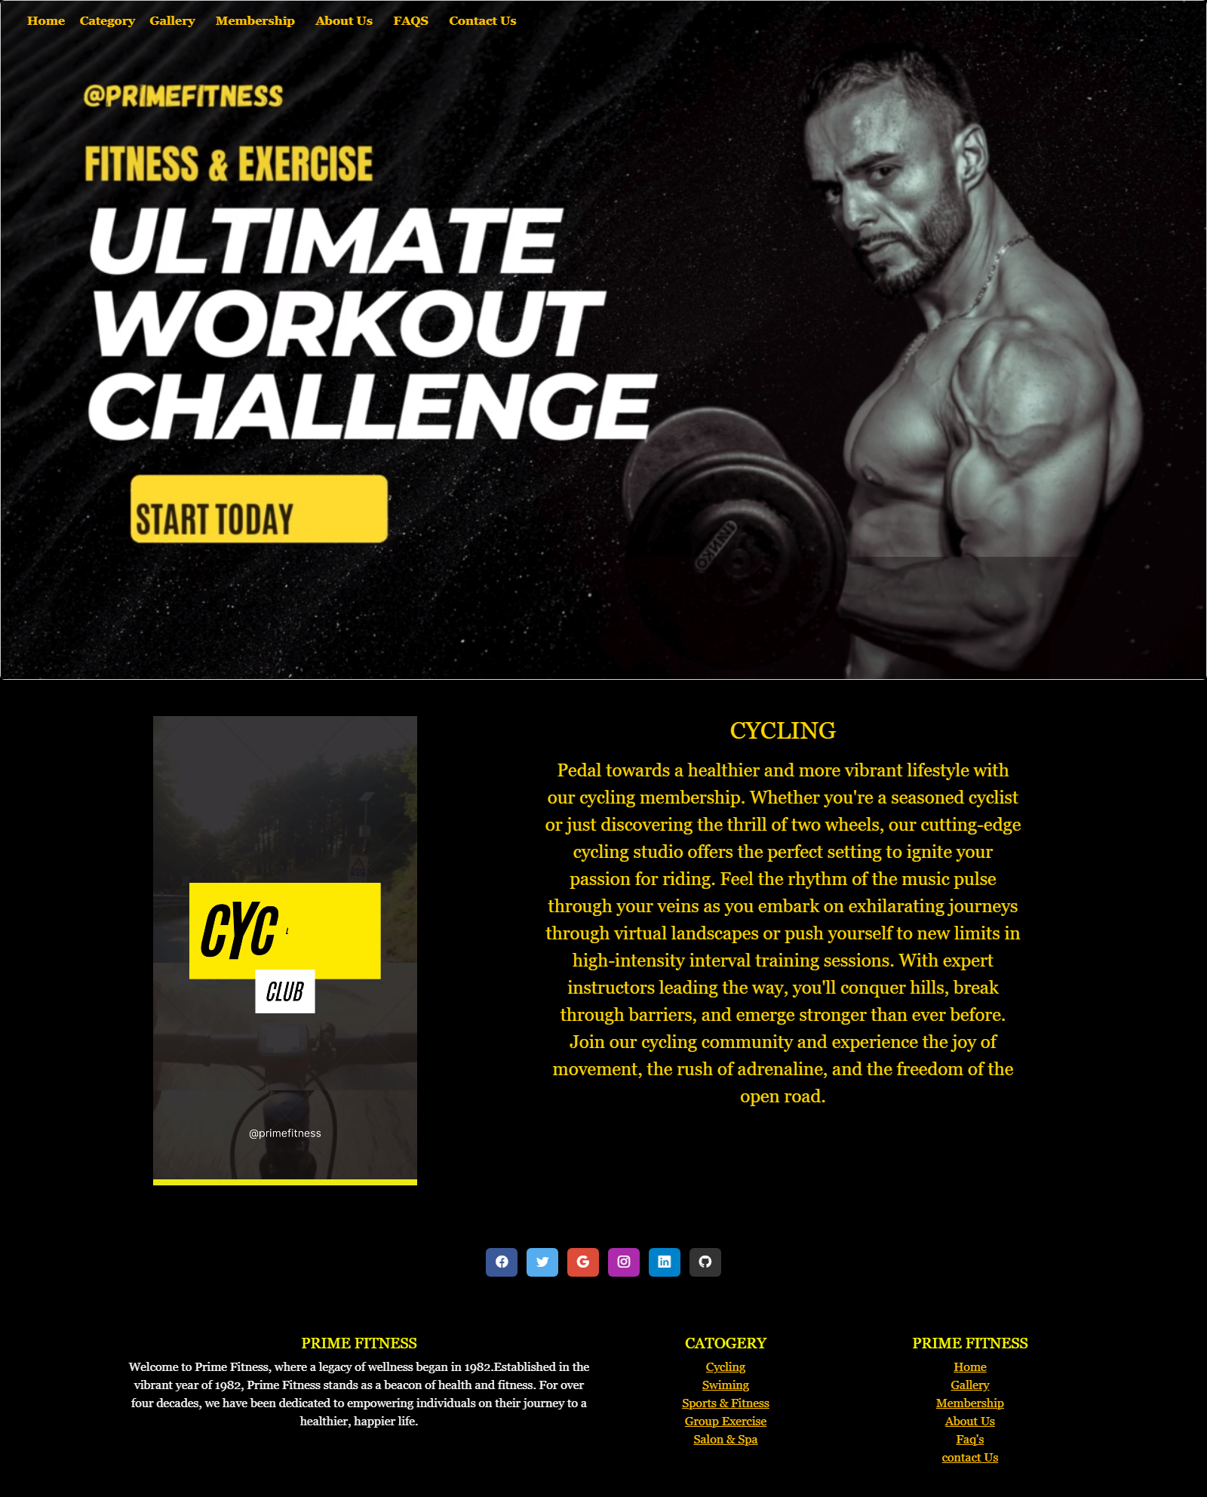

<!DOCTYPE html>

<html lang="en">

<head>

    <meta charset="UTF-8">

    <meta name="viewport" content="width=device-width, initial-scale=1.0">

    <title>CYCLING</title>

    <link href="https://cdn.jsdelivr.net/npm/bootstrap@5.3.2/dist/css/bootstrap.min.css" rel="stylesheet"

        integrity="sha384-T3c6CoIi6uLrA9TneNEoa7RxnatzjcDSCmG1MXxSR1GAsXEV/Dwwykc2MPK8M2HN" crossorigin="anonymous">

    <script src="https://cdn.jsdelivr.net/npm/bootstrap@5.3.3/dist/js/bootstrap.bundle.min.js"

        integrity="sha384-YvpcrYf0tY3lHB60NNkmXc5s9fDVZLESaAA55NDzOxhy9GkcIdslK1eN7N6jIeHz"

        crossorigin="anonymous"></script>

             <!-- icon CDN -->

  <link rel="stylesheet" href="https://cdn.jsdelivr.net/npm/bootstrap-icons@1.11.3/font/bootstrap-icons.min.css">

  <!-- Icon ENd -->

    <style>

        body {

            background-color: black;

            color: gold;

            font-family: Georgia, 'Times New Roman', Times, serif;

        }

    /* Additional styling to remove button-like appearance */

    .custom-dropdown {

      display: inline-block;

      position: relative;

      cursor: pointer;

    }

    .dropdown-menu {

      position: absolute;

      top: 100%;

      left: 0;

      z-index: 1000;

      display: none;

      float: left;

      min-width: 10rem;

      padding: .5rem 0;

      margin: .125rem 0 0;

      font-size: 1rem;

      color: #212529;

      text-align: left;

      list-style: none;

      background-color: #fff;

      background-clip: padding-box;

      border: 1px solid rgba(0, 0, 0, .15);

      border-radius: .25rem;

    }

    .custom-dropdown:hover .dropdown-menu {

      display: block;

    }

    .custom-dropdown {

      padding-top: 7.5px;

    }

    li {

      background-color: black;

    }

    .outlined-text {

      color: yellow;

      text-shadow:

        -1px -1px 0 #000,

        1px -1px 0 #000,

        -1px 1px 0 #000,

        1px 1px 0 #000;

    }

    </style>

</head>

<body>

  <marquee class="text-warning"  behavior="scroll" direction="left">

    Welcome to our website! PRIME FITNESS!!!...Your Path to a Healthier.Monday - Friday: 6:00 AM - 10:00 PM.... Saturday: 8:00 AM - 8:00 PM....Sunday: Closed

</marquee>

    <!-- Nav Start -->

    <nav class="navbar navbar-expand-lg fixed-top ">

      <div class="container-fluid">

        <a class="navbar-brand" href="../index.html">

          <img src="IMAGES/P1.png" alt="" height="60px">

        </a>

        <button class="navbar-toggler" type="button" data-bs-toggle="collapse" data-bs-target="#navbarNavAltMarkup"

          aria-controls="navbarNavAltMarkup" aria-expanded="false" aria-label="Toggle navigation">

          <span class="navbar-toggler-icon " style="background-color: #f0ec08;"></span>

        </button>

        <div class="collapse navbar-collapse" id="navbarNavAltMarkup">

          <div class="navbar-nav">

            <a class="nav-link active text-warning" href="../index.html"><b>Home</b></a>

            &nbsp;

            &nbsp;

            <div class="custom-dropdown ">

              <span class="text-warning"><b>Category</b></span>

              <ul class="dropdown-menu text-bg-dark">

                <li><a class="dropdown-item text-bg-dark text-warning" href="cycling.html">Cycling</a></li>

                <li><a class="dropdown-item text-bg-dark text-warning" href="swim.html">Swiming</a></li>

                <li><a class="dropdown-item text-bg-dark text-warning" href="../Sports & Fitness.html">Sports & Fitness</a>

                </li>

                <li><a class="dropdown-item text-bg-dark text-warning" href="group exercise.html">Group Exercise</a></li>

                <li><a class="dropdown-item text-bg-dark text-warning" href="salon and spa.html">Salon & Spa</a></li>

              </ul>

            </div>

            &nbsp;

            &nbsp;

            <a class="nav-link active text-warning" href="../Gallery/gallery.html"><b>Gallery</b></a>

            &nbsp;

            &nbsp;

            <a class="nav-link active text-warning" href="../membership.html"><b>Membership</b></a>

            &nbsp;

            &nbsp;

            <a class="nav-link active text-warning" href="../about us/about us.html"><b>About Us</b></a>

            &nbsp;

            &nbsp;

            <a class="nav-link active text-warning" href="../faq.html"><b>FAQS</b></a>

            &nbsp;

            &nbsp;

            <a class="nav-link active text-warning" href="../contact us .html"><b>Contact Us</b></a>

          </div>

        </div>

      </div>

    </nav>

    <!-- Nav End -->

    <!-- Carousel Start -->

    <div class="card" style="width: 100%px;">

      <video loop autoplay loop muted loop>

        <source src="../video/b7.mp4" type="video/mp4">

      </video>

    </div>

    <!-- Carousel End -->

    <div class="container m-5">

        <div class="row">

            <div class="col-lg-6 col-md-6 col-sm-12 text-center">

                <video loop autoplay loop muted loop width="350px">

                    <source src="images/b1.mp4" type="video/mp4">

                  </video>

            </div>

            <div class="col-lg-6 col-md-6 col-sm-12 d-flex justify-content-center">

                <div class="text-center">

                    <div class=" product_details">

                        <h2 id="name" class="mb-3">CYCLING</h2>

                    </div>

                    <div class="text-center fs-4 discription write">

                        <p> Pedal towards a healthier and more vibrant lifestyle with our cycling membership. Whether you're a seasoned

                            cyclist or just discovering the thrill of two wheels, our cutting-edge cycling studio offers the perfect setting

                            to ignite your passion for riding. Feel the rhythm of the music pulse through your veins as you embark on

                            exhilarating journeys through virtual landscapes or push yourself to new limits in high-intensity interval

                            training sessions. With expert instructors leading the way, you'll conquer hills, break through barriers, and

                            emerge stronger than ever before. Join our cycling community and experience the joy of movement, the rush of

                            adrenaline, and the freedom of the open road.

                        </p>

                    </div>

                </div>

            </div>

        </div>

    </div>

     <!-- footer stART  -->

  <footer class=" text-center" style="background-color: #000;">

    <!-- Grid container -->

    <div class="container p-4 pb-0">

      <!-- Section: Social media -->

      <section class="mb-4 pb-4">

        <!-- Facebook -->

        <a data-mdb-ripple-init class="btn text-white btn-floating m-1" style="background-color: #3b5998;" href="https://www.facebook.com/atmospherefitnesspk/" target="_blank"

          role="button"><i class="bi bi-facebook"></i></a>

        <!-- Twitter -->

        <a data-mdb-ripple-init class="btn text-white btn-floating m-1" style="background-color: #55acee;" href="https://twitter.com/GymBodyFitness_" target="_blank"

          role="button"><i class="bi bi-twitter"></i></a>

        <!-- Google -->

        <a data-mdb-ripple-init class="btn text-white btn-floating m-1" style="background-color: #dd4b39;" href="https://www.google.com/webhp?hl=en&sa=X&ved=0ahUKEwjsofiW5cuEAxUv_bsIHWLMDtoQPAgJ" target="_blank"

          role="button"><i class="bi bi-google"></i></a>

        <!-- Instagram -->

        <a data-mdb-ripple-init class="btn text-white btn-floating m-1" style="background-color: #ac2bac;" href="https://www.instagram.com/primefitnesspakistan/" target="_blank"

          role="button"><i class="bi bi-instagram"></i></a>

        <!-- Linkedin -->

        <a data-mdb-ripple-init class="btn text-white btn-floating m-1" style="background-color: #0082ca;" href="https://www.linkedin.com/login" target="_blank"

          role="button"><i class="bi bi-linkedin"></i></a>

        <!-- Github -->

        <a data-mdb-ripple-init class="btn text-white btn-floating m-1" style="background-color: #333333;" href="https://github.com/login" target="_blank"

          role="button"><i class="bi bi-github"></i></a>

      </section>

      <!-- Section: Social media -->

    </div>

    <!-- Grid container -->

  </footer>

  <!-- second footer -->

  <section class="">

    <!-- Footer -->

    <footer class=" text-center" style="background-color: #000;">

      <!-- Grid container -->

      <div class="container p-4">

        <!--Grid row-->

        <div class="row">

          <!--Grid column-->

          <div class="col-lg-6 col-md-12 mb-4 mb-md-0">

            <h5 class="text-uppercase outlined-text">Prime Fitness</h5>

            <p class="text-light">

              Welcome to Prime Fitness, where a legacy of wellness began in 1982.Established in the vibrant year of

              1982, Prime Fitness stands as a beacon of health and fitness. For over four decades, we have been

              dedicated to empowering individuals on their journey to a healthier, happier life.

            </p>

          </div>

          <!--Grid column-->

          <!--Grid column-->

          <div class="col-lg-3 col-md-6 mb-4 mb-md-0">

            <h5 class="text-uppercase outlined-text">Catogery</h5>

            <ul class="list-unstyled mb-0">

              <li>

                <a href="../catogary/cycling.html" class="text-warning">Cycling</a>

              </li>

              <li>

                <a href="../catogary/swim.html" class="text-warning">Swiming</a>

              </li>

              <li>

                <a href="../Sports & Fitness.html & Fitness.html" class="text-warning">Sports & Fitness</a>

              </li>

              <li>

                <a href="../catogary/group exercise.html " class="text-warning">Group Exercise</a>

              </li>

              <li>

                <a href="../catogary/salon and spa.html" class="text-warning">Salon & Spa</a>

              </li>

            </ul>

          </div>

          <!--Grid column-->

          <!--Grid column-->

          <div class="col-lg-3 col-md-6 mb-4 mb-md-0">

            <h5 class="text-uppercase outlined-text">Prime Fitness</h5>

            <ul class="list-unstyled">

              <li>

                <a href="../index.html" class="text-warning">Home</a>

              </li>

              <li>

                <a href="../Gallery/gallery.html" class="text-warning">Gallery</a>

              </li>

              <li>

                <a href="../membership.html" class="text-warning">Membership </a>

              </li>

              <li>

                <a href="../about us/about us.html " class="text-warning">About Us</a>

              </li>

              <li>

                <a href="../faq.html" class="text-warning">Faq's</a>

              </li>

              <li>

                <a href="../contact us .html" class="text-warning">contact Us</a>

              </li>

            </ul>

          </div>

          <!--Grid column-->

        </div>

        <!--Grid row-->

      </div>

      <!-- Grid container -->

      <!-- Copyright -->

      <!-- <div class="text-center p-3" style="background-color: rgba(0, 0, 0, 0.05);">

        © 2020 Copyright:

        <a class="text-body" href="https://mdbootstrap.com/">MDBootstrap.com</a>

      </div> -->

      <!-- Copyright -->

    </footer>

    <!-- Footer -->

  </section>

  <!-- footer end  -->

</body>

</html>

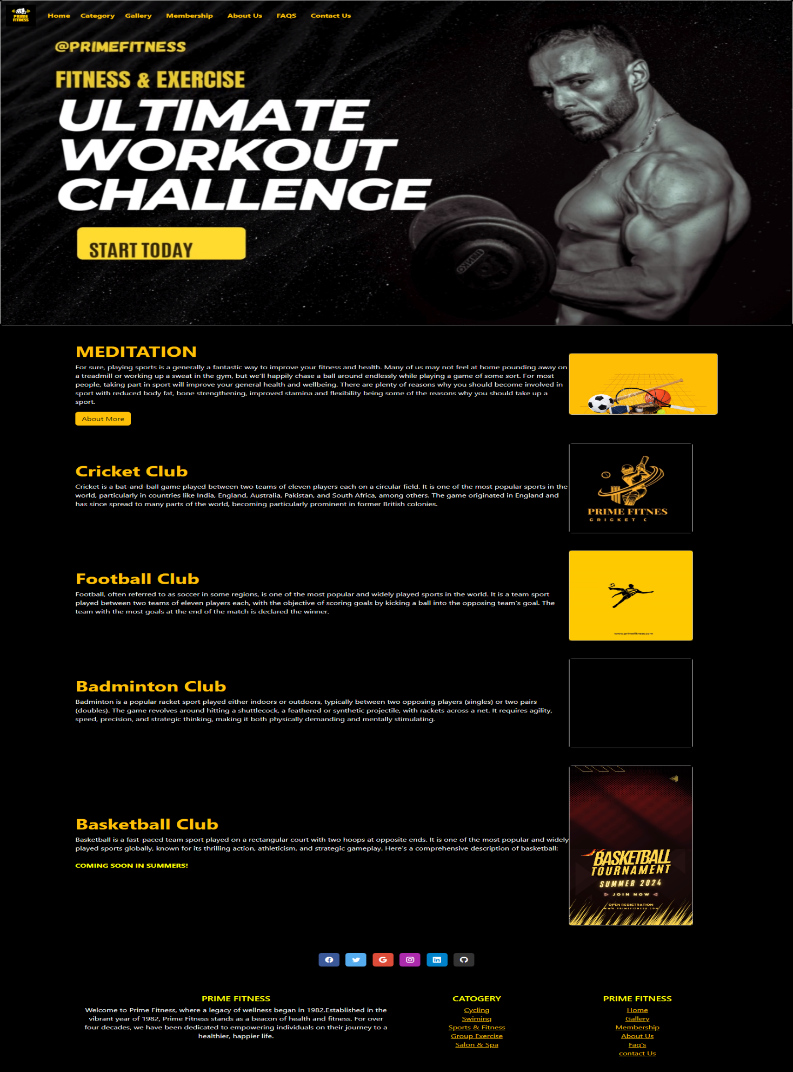

<!DOCTYPE html>

<html lang="en">

<head>

  <meta charset="UTF-8">

  <meta name="viewport" content="width=device-width, initial-scale=1.0">

  <title>Home|Catogaries|Sports & Fitness</title>

  <!-- CDN start -->

  <link href="https://cdn.jsdelivr.net/npm/bootstrap@5.3.2/dist/css/bootstrap.min.css" rel="stylesheet"

    integrity="sha384-T3c6CoIi6uLrA9TneNEoa7RxnatzjcDSCmG1MXxSR1GAsXEV/Dwwykc2MPK8M2HN" crossorigin="anonymous">

  <script src="https://cdn.jsdelivr.net/npm/bootstrap@5.3.2/dist/js/bootstrap.bundle.min.js"

    integrity="sha384-C6RzsynM9kWDrMNeT87bh95OGNyZPhcTNXj1NW7RuBCsyN/o0jlpcV8Qyq46cDfL"

    crossorigin="anonymous"></script>

  <!-- CDN end -->

  <!-- icon CDN -->

  <link rel="stylesheet" href="https://cdn.jsdelivr.net/npm/bootstrap-icons@1.11.3/font/bootstrap-icons.min.css">

  <!-- Icon ENd -->

</head>

<style>

  .flex-container {

    display: flex;

    align-items: center;

  }

  .flex-item {

    flex: 1;

  }

  .image-container {

    max-width: 300px;

  }

  img {

    max-width: 100%;

    height: auto;

  }

  .outlined-text {

    color: yellow;

    text-shadow:

      -1px -1px 0 #000,

      1px -1px 0 #000,

      -1px 1px 0 #000,

      1px 1px 0 #000;

  }

  .custom-dropdown {

    display: inline-block;

    position: relative;

    cursor: pointer;

  }

  .dropdown-menu {

    position: absolute;

    top: 100%;

    left: 0;

    z-index: 1000;

    display: none;

    float: left;

    min-width: 10rem;

    padding: .5rem 0;

    margin: .125rem 0 0;

    font-size: 1rem;

    color: #212529;

    text-align: left;

    list-style: none;

    background-color: #fff;

    background-clip: padding-box;

    border: 1px solid rgba(0, 0, 0, .15);

    border-radius: .25rem;

  }

  .custom-dropdown:hover .dropdown-menu {

    display: block;

  }

  .custom-dropdown {

    padding-top: 7.5px;

  }

  li {

    background-color: black;

  }

</style>

</head>

<body class="bg-black">

  <marquee class="text-warning"  behavior="scroll" direction="left">

    Welcome to our website! PRIME FITNESS!!!...Your Path to a Healthier.Monday - Friday: 6:00 AM - 10:00 PM.... Saturday: 8:00 AM - 8:00 PM....Sunday: Closed

</marquee>

  <!-- Nav Start -->

  <nav class="navbar navbar-expand-lg  fixed-top ">

    <div class="container-fluid">

      <a class="navbar-brand" href="index.html">

        <img src="IMAGES/P1.png" height="60px" width="60px">

      </a>

      <button class="navbar-toggler" type="button" data-bs-toggle="collapse" data-bs-target="#navbarNavAltMarkup"

        aria-controls="navbarNavAltMarkup" aria-expanded="false" aria-label="Toggle navigation">

        <span class="navbar-toggler-icon"></span>

      </button>

      <div class="collapse navbar-collapse" id="navbarNavAltMarkup">

        <div class="navbar-nav">

          <a class="nav-link active text-warning" href="index.html"><b>Home</b></a>

          &nbsp;

          &nbsp;

          <div class="custom-dropdown ">

            <span class="text-warning"><b>Category</b></span>

            <ul class="dropdown-menu text-bg-dark">

              <li><a class="dropdown-item text-bg-dark text-warning" href="catogary/cycling.html">Cycling</a></li>

              <li><a class="dropdown-item text-bg-dark text-warning" href="catogary/swim.html">Swiming</a></li>

              <li><a class="dropdown-item text-bg-dark text-warning" href="Sports & Fitness.html">Sports & Fitness</a>

              </li>

              <li><a class="dropdown-item text-bg-dark text-warning" href="catogary/group exercise.html">Group Exercise</a></li>

              <li><a class="dropdown-item text-bg-dark text-warning" href="catogary/salon and spa.html">Salon & Spa</a></li>

            </ul>

          </div>

          &nbsp;

          &nbsp;

          <a class="nav-link active text-warning" href="Gallery/gallery.html"><b>Gallery</b></a>

          &nbsp;

          &nbsp;

          <a class="nav-link active text-warning" href="membership.html"><b>Membership</b></a>

          &nbsp;

          &nbsp;

          <a class="nav-link active text-warning" href="about us/about us.html"><b>About Us</b></a>

          &nbsp;

          &nbsp;

          <a class="nav-link active text-warning" href="faq.html"><b>FAQS</b></a>

          &nbsp;

          &nbsp;

          <a class="nav-link active text-warning" href="contact us .html"><b>Contact Us</b></a>

        </div>

      </div>

    </div>

  </nav>

  <!-- Nav End -->

  <!-- Carousel Start -->

  <div class="card" style="width: 100%px;">

    <video loop autoplay loop muted loop>

      <source src="video/b7.mp4" type="video/mp4">

    </video>

  </div>

  <!-- Carousel End -->

<!-- flex1 -->

  <div class="container">

    <div class="row mt-5 mb-5">

      <div class="col ">

        <div class="flex-container">

          <div class="flex-item">

            <h1 class="text-warning outlined-text"><b>MEDITATION</b></h1>

            <p class="text-light">For sure, playing sports is a generally a fantastic way to improve

              your fitness and health. Many of us may not feel at home pounding away on a treadmill or

              working up a sweat in the gym, but we’ll happily chase a ball around endlessly while

              playing a game of some sort. For most people, taking part in sport will improve your

              general health and wellbeing. There are plenty of reasons why you should become involved

              in sport with reduced body fat, bone strengthening, improved stamina and flexibility

              being some of the reasons why you should take up a sport.</p>

            <a href="About More.html" class="btn btn-warning">About More</a>

          </div>

          <div class="flex-item image-container">

            <div class="card" style="width: 100%px;">

              <video loop autoplay loop muted loop>

                <source src="sports Videos/b1.mp4" type="video/mp4">

              </video>

            </div>

          </div>

        </div>

      </div>

    </div>

  </div>

<!-- flex1 EnD -->

 <!-- flex2 Start -->

 <div class="container">

  <div class="row mt-5 mb-5">

    <div class="col">

      <div class="flex-container">

        <div class="flex-item">

          <h1 class="text-warning outlined-text"><b>Cricket Club</b></h1>

          <p class="text-light">Cricket is a bat-and-ball game played between two teams of eleven players each on a circular field. It is one of the most popular sports in the world, particularly in countries like India, England, Australia, Pakistan, and South Africa, among others. The game originated in England and has since spread to many parts of the world, becoming particularly prominent in former British colonies.</p>

        </div>

        <div class="flex-item image-container">

          <div class="card" style="width:250px;">

            <video loop autoplay loop muted loop>

              <source src="sports Videos/b10.mp4" type="video/mp4">

            </video>

          </div>

        </div>

      </div>

    </div>

  </div>

</div>

  <!-- flex 2 ENd -->

  <!-- flex 3 Start -->

  <div class="container">

  <div class="row mt-5 mb-5">

    <div class="col">

      <div class="flex-container">

        <div class="flex-item">

          <h1 class="text-warning outlined-text"><b>Football Club</b></h1>

          <p class="text-light">Football, often referred to as soccer in some regions, is one of the most popular and widely played sports in the world. It is a team sport played between two teams of eleven players each, with the objective of scoring goals by kicking a ball into the opposing team's goal. The team with the most goals at the end of the match is declared the winner.</p>

        </div>

        <div class="flex-item image-container">

          <div class="card" style="width:250px;">

            <video loop autoplay loop muted loop>

              <source src="sports Videos/b11.mp4" type="video/mp4">

            </video>

          </div>

        </div>

      </div>

    </div>

  </div>

</div>

<!-- flex 3 End -->

<!-- flex 4 Start -->

<div class="container">

  <div class="row mt-5 mb-5">

    <div class="col">

      <div class="flex-container">

        <div class="flex-item">

          <h1 class="text-warning outlined-text"><b>Badminton Club</b></h1>

          <p class="text-light">Badminton is a popular racket sport played either indoors or outdoors, typically between two opposing players (singles) or two pairs (doubles). The game revolves around hitting a shuttlecock, a feathered or synthetic projectile, with rackets across a net. It requires agility, speed, precision, and strategic thinking, making it both physically demanding and mentally stimulating.</p>

        </div>

        <div class="flex-item image-container">

          <div class="card" style="width:250px;">

            <video loop autoplay loop muted loop>

              <source src="sports Videos/b12.mp4" type="video/mp4">

            </video>

          </div>

        </div>

      </div>

    </div>

  </div>

</div>

<!-- flex 4 End -->

<!-- flex 5 Start -->

<div class="container">

  <div class="row mt-5 mb-5">

    <div class="col">

      <div class="flex-container">

        <div class="flex-item">

          <h1 class="text-warning outlined-text"><b>Basketball Club</b></h1>

          <p class="text-light">Basketball is a fast-paced team sport played on a rectangular court with two hoops at opposite ends. It is one of the most popular and widely played sports globally, known for its thrilling action, athleticism, and strategic gameplay. Here's a comprehensive description of basketball:

            <br>

            <br>

           <b class="outlined-text" >COMING SOON IN SUMMERS!</b>

          </p>

        </div>

        <div class="flex-item image-container">

          <div class="card" style="width:250px;">

            <video loop autoplay loop muted loop>

              <source src="sports Videos/b13.mp4" type="video/mp4">

            </video>

          </div>

        </div>

      </div>

    </div>

  </div>

</div>

  <!-- footer stART  -->

  <footer class=" text-center" style="background-color: #000;">

    <!-- Grid container -->

    <div class="container p-4 pb-0">

      <!-- Section: Social media -->

      <section class="mb-4 pb-4">

        <!-- Facebook -->

        <a data-mdb-ripple-init class="btn text-white btn-floating m-1" style="background-color: #3b5998;" href="https://www.facebook.com/atmospherefitnesspk/" target="_blank"

          role="button"><i class="bi bi-facebook"></i></a>

        <!-- Twitter -->

        <a data-mdb-ripple-init class="btn text-white btn-floating m-1" style="background-color: #55acee;" href="https://twitter.com/GymBodyFitness_" target="_blank"

          role="button"><i class="bi bi-twitter"></i></a>

        <!-- Google -->

        <a data-mdb-ripple-init class="btn text-white btn-floating m-1" style="background-color: #dd4b39;" href="https://www.google.com/webhp?hl=en&sa=X&ved=0ahUKEwjsofiW5cuEAxUv_bsIHWLMDtoQPAgJ" target="_blank"

          role="button"><i class="bi bi-google"></i></a>

        <!-- Instagram -->

        <a data-mdb-ripple-init class="btn text-white btn-floating m-1" style="background-color: #ac2bac;" href="https://www.instagram.com/primefitnesspakistan/" target="_blank"

          role="button"><i class="bi bi-instagram"></i></a>

        <!-- Linkedin -->

        <a data-mdb-ripple-init class="btn text-white btn-floating m-1" style="background-color: #0082ca;" href="https://www.linkedin.com/login" target="_blank"

          role="button"><i class="bi bi-linkedin"></i></a>

        <!-- Github -->

        <a data-mdb-ripple-init class="btn text-white btn-floating m-1" style="background-color: #333333;" href="https://github.com/login" target="_blank"

          role="button"><i class="bi bi-github"></i></a>

      </section>

      <!-- Section: Social media -->

    </div>

    <!-- Grid container -->

  </footer>

  <!-- second footer -->

  <section class="">

    <!-- Footer -->

    <footer class=" text-center" style="background-color: #000;">

      <!-- Grid container -->

      <div class="container p-4">

        <!--Grid row-->

        <div class="row">

          <!--Grid column-->

          <div class="col-lg-6 col-md-12 mb-4 mb-md-0">

            <h5 class="text-uppercase outlined-text">Prime Fitness</h5>

            <p class="text-light">

              Welcome to Prime Fitness, where a legacy of wellness began in 1982.Established in the vibrant year of

              1982, Prime Fitness stands as a beacon of health and fitness. For over four decades, we have been

              dedicated to empowering individuals on their journey to a healthier, happier life.

            </p>

          </div>

          <!--Grid column-->

          <!--Grid column-->

          <div class="col-lg-3 col-md-6 mb-4 mb-md-0">

            <h5 class="text-uppercase outlined-text">Catogery</h5>

            <ul class="list-unstyled mb-0">

              <li>

                <a href="catogary/cycling.html" class="text-warning">Cycling</a>

              </li>

              <li>

                <a href="catogary/swim.html" class="text-warning">Swiming</a>

              </li>

              <li>

                <a href="Sports & Fitness.html" class="text-warning">Sports & Fitness</a>

              </li>

              <li>

                <a href="catogary/group exercise.html" class="text-warning">Group Exercise</a>

              </li>

              <li>

                <a href="catogary/salon and spa.html" class="text-warning">Salon & Spa</a>

              </li>

            </ul>

          </div>

          <!--Grid column-->

          <!--Grid column-->

          <div class="col-lg-3 col-md-6 mb-4 mb-md-0">

            <h5 class="text-uppercase outlined-text">Prime Fitness</h5>

            <ul class="list-unstyled">

              <li>

                <a href="index.html" class="text-warning">Home</a>

              </li>

              <li>

                <a href="Gallery/gallery.html" class="text-warning">Gallery</a>

              </li>

              <li>

                <a href="membership.html" class="text-warning">Membership </a>

              </li>

              <li>

                <a href="about us/about us.html" class="text-warning">About Us</a>

              </li>

              <li>

                <a href="faq.html" class="text-warning">Faq's</a>

              </li>

              <li>

                <a href="contact us .html" class="text-warning">contact Us</a>

              </li>

            </ul>

          </div>

          <!--Grid column-->

        </div>

        <!--Grid row-->

      </div>

      <!-- Grid container -->

      <!-- Copyright -->

      <!-- <div class="text-center p-3" style="background-color: rgba(0, 0, 0, 0.05);">

        © 2020 Copyright:

        <a class="text-body" href="https://mdbootstrap.com/">MDBootstrap.com</a>

      </div> -->

      <!-- Copyright -->

    </footer>

    <!-- Footer -->

  </section>

  <!-- footer end  -->

</body>

</html>

GALLERY: 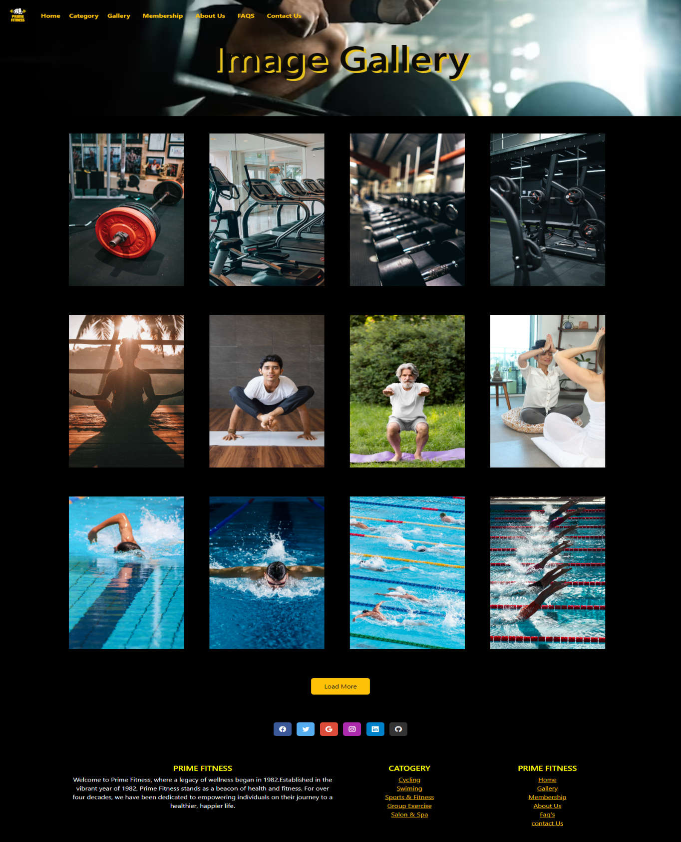

<!DOCTYPE html>

<html lang="en">

<head>

    <meta charset="UTF-8">

    <meta name="viewport" content="width=device-width, initial-scale=1.0">

    <!-- BOOTSTRAP CSS -->

    <link href="https://cdn.jsdelivr.net/npm/bootstrap@5.3.2/dist/css/bootstrap.min.css" rel="stylesheet"

        integrity="sha384-T3c6CoIi6uLrA9TneNEoa7RxnatzjcDSCmG1MXxSR1GAsXEV/Dwwykc2MPK8M2HN" crossorigin="anonymous">

    <link rel="stylesheet" href="gallery.css">

    <title>Home|Gallery</title>

    <!-- icon CDN -->

    <link rel="stylesheet" href="https://cdn.jsdelivr.net/npm/bootstrap-icons@1.11.3/font/bootstrap-icons.min.css">

    <!-- Icon ENd -->

    <style>

        body {

            background-color: #000;

        }

        .custom-dropdown {

            display: inline-block;

            position: relative;

            cursor: pointer;

        }

        .dropdown-menu {

            position: absolute;

            top: 100%;

            left: 0;

            z-index: 1000;

            display: none;

            float: left;

            min-width: 10rem;

            padding: .5rem 0;

            margin: .125rem 0 0;

            font-size: 1rem;

            color: #212529;

            text-align: left;

            list-style: none;

            background-color: #fff;

            background-clip: padding-box;

            border: 1px solid rgba(0, 0, 0, .15);

            border-radius: .25rem;

        }

        .custom-dropdown:hover .dropdown-menu {

            display: block;

        }

        .custom-dropdown {

            padding-top: 7.5px;

        }

        li {

            background-color: black;

        }

        .outlined-text {

            color: yellow;

            text-shadow:

                -1px -1px 0 #000,

                1px -1px 0 #000,

                -1px 1px 0 #000,

                1px 1px 0 #000;

        }

    </style>

</head>

<body>

    <marquee class="text-warning"  behavior="scroll" direction="left">

        Welcome to our website! PRIME FITNESS!!!...Your Path to a Healthier.Monday - Friday: 6:00 AM - 10:00 PM.... Saturday: 8:00 AM - 8:00 PM....Sunday: Closed

    </marquee>

    <!-- Nav Start -->

    <nav class="navbar navbar-expand-lg fixed-top">

        <div class="container-fluid">

            <a class="navbar-brand" href="index.html">

                <img src="Images/P1.png" alt="" height="60px" width="60px">

            </a>

            <button class="navbar-toggler" type="button" data-bs-toggle="collapse" data-bs-target="#navbarNavAltMarkup"

                aria-controls="navbarNavAltMarkup" aria-expanded="false" aria-label="Toggle navigation">

                <span class="navbar-toggler-icon"></span>

            </button>

            <div class="collapse navbar-collapse" id="navbarNavAltMarkup">

                <div class="navbar-nav">

                    <a class="nav-link active text-warning" href="../index.html"><b>Home</b></a>

                    &nbsp;

                    &nbsp;

                    <div class="custom-dropdown ">

                        <span class="text-warning"><b>Category</b></span>

                        <ul class="dropdown-menu text-bg-dark">

                            <li><a class="dropdown-item text-bg-dark text-warning" href="../catogary/cycling.html">Cycling</a></li>

                            <li><a class="dropdown-item text-bg-dark text-warning" href="../catogary/swim.html">Swiming</a></li>

                            <li><a class="dropdown-item text-bg-dark text-warning"

                                    href="../Sports & Fitness.html">Sports & Fitness</a></li>

                            <li><a class="dropdown-item text-bg-dark text-warning" href="../catogary/group exercise.html">Group Exercise</a></li>

                            <li><a class="dropdown-item text-bg-dark text-warning" href="../catogary/salon and spa.html">Salon & Spa</a></li>

                        </ul>

                    </div>

                    &nbsp;

                    &nbsp;

                    <a class="nav-link active text-warning" href="Gallery/gallery.html"><b>Gallery</b></a>

                    &nbsp;

                    &nbsp;

                    <a class="nav-link active text-warning" href="../membership.html"><b>Membership</b></a>

                    &nbsp;

                    &nbsp;

                    <a class="nav-link active text-warning" href="../about us/about us.html"><b>About Us</b></a>

                    &nbsp;

                    &nbsp;

                    <a class="nav-link active text-warning" href="../faq.html"><b>FAQS</b></a>

                    &nbsp;

                    &nbsp;

                    <a class="nav-link active text-warning" href="../contact us .html"><b>Contact Us</b></a>

                </div>

            </div>

        </div>

    </nav>

    <!-- Nav End -->

    <!-- intro start -->

    <div class="d-flex justify-content-center text-white intro">

        <h1>Image Gallery</h1>

    </div>

    <!-- intro end -->

    <div class="container  mt-5">

        <div class="row">

            <div class="col-lg-3 col-md-4 col-sm-6 blogBox moreBox" style="display: none;">

                <div class="special-card">

                    <div class="image img1 zoom-in" ></div>

                </div>

            </div>

            <div class="col-lg-3 col-md-4 col-sm-6 blogBox moreBox" style="display: none;">

                <div class="special-card">

                    <div class="image img2 zoom-in" ></div>

                </div>

            </div>

            <div class="col-lg-3 col-md-4 col-sm-6 blogBox moreBox" style="display: none;">

                <div class="special-card">

                    <div class="image img3 zoom-in" ></div>

                </div>

            </div>

            <div class="col-lg-3 col-md-4 col-sm-6  blogBox moreBox" style="display: none;">

                <div class="special-card">

                    <div class="image img4 zoom-in" ></div>

                </div>

            </div>

            <div class="col-md-3 blogBox moreBox" style="display: none;">

                <div class="special-card">

                    <div class="image img5 zoom-in"></div>

                </div>

            </div>

            <div class="col-md-3 blogBox moreBox" style="display: none;">

                <div class="special-card">

                    <div class="image img6 zoom-in"></div>

                </div>

            </div>

            <div class="col-md-3 blogBox moreBox" style="display: none;">

                <div class="special-card">

                    <div class="image img7 zoom-in"></div>

                </div>

            </div>

            <div class="col-md-3 blogBox moreBox" style="display: none;">

                <div class="special-card">

                    <div class="image img8 zoom-in"></div>

                </div>

            </div>

            <div class="col-md-3 blogBox moreBox" style="display: none;">

                <div class="special-card">

                    <div class="image img9 zoom-in"></div>

                </div>

            </div>

            <div class="col-md-3 blogBox moreBox" style="display: none;">

                <div class="special-card">

                    <div class="image img10 zoom-in"></div>

                </div>

            </div>

            <div class="col-md-3 blogBox moreBox" style="display: none;">

                <div class="special-card">

                    <div class="image img11 zoom-in"></div>

                </div>

            </div>

            <div class="col-md-3 blogBox moreBox" style="display: none;">

                <div class="special-card">

                    <div class="image img12 zoom-in"></div>

                </div>

            </div>

            <div class="col-md-3 blogBox moreBox" style="display: none;">

                <div class="special-card">

                    <div class="image img13 zoom-in"></div>

                </div>

            </div>

            <div class="col-md-3 blogBox moreBox" style="display: none;">

                <div class="special-card">

                    <div class="image img14 zoom-in"></div>

                </div>

            </div>

            <div class="col-md-3 blogBox moreBox" style="display: none;">

                <div class="special-card">

                    <div class="image img15 zoom-in"></div>

                </div>

            </div>

            <div class="col-md-3 blogBox moreBox" style="display: none;">

                <div class="special-card">

                    <div class="image img16 zoom-in"></div>

                </div>

            </div>

            <div class="col-md-3 blogBox moreBox" style="display: none;">

                <div class="special-card">

                    <div class="image img17 zoom-in"></div>

                </div>

            </div>

            <div class="col-md-3 blogBox moreBox" style="display: none;">

                <div class="special-card">

                    <div class="image img18 zoom-in"></div>

                </div>

            </div>

            <div class="col-md-3 blogBox moreBox" style="display: none;">

                <div class="special-card">

                    <div class="image img19 zoom-in"></div>

                </div>

            </div>

            <div class="col-md-3 blogBox moreBox" style="display: none;">

                <div class="special-card">

                    <div class="image img20 zoom-in"></div>

                </div>

            </div>

            <div class="col-md-3 blogBox moreBox" style="display: none;">

                <div class="special-card">

                    <div class="image img21 zoom-in"></div>

                </div>

            </div>

            <div class="col-md-3 blogBox moreBox" style="display: none;">

                <div class="special-card">

                    <div class="image img22 zoom-in"></div>

                </div>

            </div>

            <div class="col-md-3 blogBox moreBox" style="display: none;">

                <div class="special-card">

                    <div class="image img23 zoom-in"></div>

                </div>

            </div>

            <div class="col-md-3 blogBox moreBox" style="display: none;">

                <div class="special-card">

                    <div class="image img24 zoom-in"></div>

                </div>

            </div>

            <div class="col-md-3 blogBox moreBox" style="display: none;">

                <div class="special-card">

                    <div class="image img25 zoom-in"></div>

                </div>

            </div>

            <div class="col-md-3 blogBox moreBox" style="display: none;">

                <div class="special-card">

                    <div class="image img26 zoom-in"></div>

                </div>

            </div>

            <div class="col-md-3 blogBox moreBox" style="display: none;">

                <div class="special-card">

                    <div class="image img27 zoom-in"></div>

                </div>

            </div>

            <div class="col-md-3 blogBox moreBox" style="display: none;">

                <div class="special-card">

                    <div class="image img28 zoom-in"></div>

                </div>

            </div>

            <div class="d-flex justify-content-center mb-5">

                <a id="loadMore" class="btn btn-warning text-decoration-none">Load More</a>

            </div>

        </div>

    </div>

    <!-- gallery end -->

    <!-- footer stART  -->

  <footer class=" text-center" style="background-color: #000;">

    <!-- Grid container -->

    <div class="container p-4 pb-0">

      <!-- Section: Social media -->

      <section class="mb-4 pb-4">

        <!-- Facebook -->

        <a data-mdb-ripple-init class="btn text-white btn-floating m-1" style="background-color: #3b5998;" href="https://www.facebook.com/atmospherefitnesspk/" target="_blank"

          role="button"><i class="bi bi-facebook"></i></a>

        <!-- Twitter -->

        <a data-mdb-ripple-init class="btn text-white btn-floating m-1" style="background-color: #55acee;" href="https://twitter.com/GymBodyFitness_" target="_blank"

          role="button"><i class="bi bi-twitter"></i></a>

        <!-- Google -->

        <a data-mdb-ripple-init class="btn text-white btn-floating m-1" style="background-color: #dd4b39;" href="https://www.google.com/webhp?hl=en&sa=X&ved=0ahUKEwjsofiW5cuEAxUv_bsIHWLMDtoQPAgJ" target="_blank"

          role="button"><i class="bi bi-google"></i></a>

        <!-- Instagram -->

        <a data-mdb-ripple-init class="btn text-white btn-floating m-1" style="background-color: #ac2bac;" href="https://www.instagram.com/primefitnesspakistan/" target="_blank"

          role="button"><i class="bi bi-instagram"></i></a>

        <!-- Linkedin -->

        <a data-mdb-ripple-init class="btn text-white btn-floating m-1" style="background-color: #0082ca;" href="https://www.linkedin.com/login" target="_blank"

          role="button"><i class="bi bi-linkedin"></i></a>

        <!-- Github -->

        <a data-mdb-ripple-init class="btn text-white btn-floating m-1" style="background-color: #333333;" href="https://github.com/login" target="_blank"

          role="button"><i class="bi bi-github"></i></a>

      </section>

      <!-- Section: Social media -->

    </div>

    <!-- Grid container -->

  </footer>

  <!-- second footer -->

  <section class="">

    <!-- Footer -->

    <footer class=" text-center" style="background-color: #000;">

      <!-- Grid container -->

      <div class="container p-4">

        <!--Grid row-->

        <div class="row">

          <!--Grid column-->

          <div class="col-lg-6 col-md-12 mb-4 mb-md-0">

            <h5 class="text-uppercase outlined-text">Prime Fitness</h5>

            <p class="text-light">

              Welcome to Prime Fitness, where a legacy of wellness began in 1982.Established in the vibrant year of

              1982, Prime Fitness stands as a beacon of health and fitness. For over four decades, we have been

              dedicated to empowering individuals on their journey to a healthier, happier life.

            </p>

          </div>

          <!--Grid column-->

          <!--Grid column-->

          <div class="col-lg-3 col-md-6 mb-4 mb-md-0">

            <h5 class="text-uppercase outlined-text">Catogery</h5>

            <ul class="list-unstyled mb-0">

              <li>

                <a href="../catogary/cycling.html" class="text-warning">Cycling</a>

              </li>

              <li>

                <a href="../catogary/swim.html" class="text-warning">Swiming</a>

              </li>

              <li>

                <a href="../Sports & Fitness.html & Fitness.html" class="text-warning">Sports & Fitness</a>

              </li>

              <li>

                <a href="../catogary/group exercise.html " class="text-warning">Group Exercise</a>

              </li>

              <li>

                <a href="../catogary/salon and spa.html" class="text-warning">Salon & Spa</a>

              </li>

            </ul>

          </div>

          <!--Grid column-->

          <!--Grid column-->

          <div class="col-lg-3 col-md-6 mb-4 mb-md-0">

            <h5 class="text-uppercase outlined-text">Prime Fitness</h5>

            <ul class="list-unstyled">

              <li>

                <a href="../index.html" class="text-warning">Home</a>

              </li>

              <li>

                <a href="../Gallery/gallery.html" class="text-warning">Gallery</a>

              </li>

              <li>

                <a href="../membership.html" class="text-warning">Membership </a>

              </li>

              <li>

                <a href="../about us/about us.html " class="text-warning">About Us</a>

              </li>

              <li>

                <a href="../faq.html" class="text-warning">Faq's</a>

              </li>

              <li>

                <a href="../contact us .html" class="text-warning">contact Us</a>

              </li>

            </ul>

          </div>

          <!--Grid column-->

        </div>

        <!--Grid row-->

      </div>

      <!-- Grid container -->

      <!-- Copyright -->

      <!-- <div class="text-center p-3" style="background-color: rgba(0, 0, 0, 0.05);">

        © 2020 Copyright:

        <a class="text-body" href="https://mdbootstrap.com/">MDBootstrap.com</a>

      </div> -->

      <!-- Copyright -->

    </footer>

    <!-- Footer -->

  </section>

  <!-- footer end  -->

    <!-- BOOTSTRAP JS -->

    <script src="https://cdn.jsdelivr.net/npm/bootstrap@5.3.2/dist/js/bootstrap.bundle.min.js"

        integrity="sha384-C6RzsynM9kWDrMNeT87bh95OGNyZPhcTNXj1NW7RuBCsyN/o0jlpcV8Qyq46cDfL"

        crossorigin="anonymous"></script>

    <!-- JQUERCY CDN -->

    <script src="https://code.jquery.com/jquery-3.7.1.min.js"

        integrity="sha256-/JqT3SQfawRcv/BIHPThkBvs0OEvtFFmqPF/lYI/Cxo=" crossorigin="anonymous"></script>

    <script src="gallery.js"></script>

</body>

</html>

MEMBERSHIP:

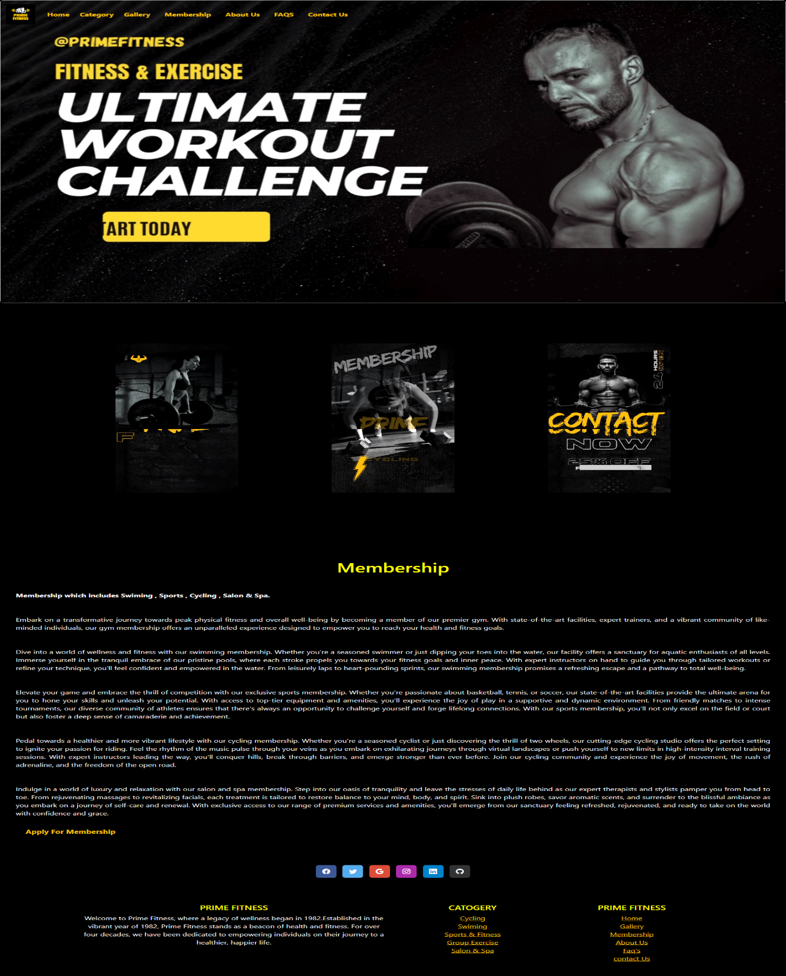

<!DOCTYPE html>

<html lang="en">

<head>

    <meta charset="UTF-8">

    <meta name="viewport" content="width=device-width, initial-scale=1.0">

    <title>Home|Membership</title>

    <!-- CDN start -->

    <link href="https://cdn.jsdelivr.net/npm/bootstrap@5.3.2/dist/css/bootstrap.min.css" rel="stylesheet"

        integrity="sha384-T3c6CoIi6uLrA9TneNEoa7RxnatzjcDSCmG1MXxSR1GAsXEV/Dwwykc2MPK8M2HN" crossorigin="anonymous">

    <script src="https://cdn.jsdelivr.net/npm/bootstrap@5.3.2/dist/js/bootstrap.bundle.min.js"

        integrity="sha384-C6RzsynM9kWDrMNeT87bh95OGNyZPhcTNXj1NW7RuBCsyN/o0jlpcV8Qyq46cDfL"

        crossorigin="anonymous"></script>

    <!-- CDN end -->

    <!-- icon CDN -->

    <link rel="stylesheet" href="https://cdn.jsdelivr.net/npm/bootstrap-icons@1.11.3/font/bootstrap-icons.min.css">

    <!-- Icon ENd -->

    <style>

        .readmore {

            margin-top: 20px;

            display: inline-block;

            color: yellow;

            padding: 10px 20px;

            background-color: black;

            font-size: 17px;

            text-decoration: none;

            font-weight: bold;

            border-radius: 10px;

            transition: 0.3s ease;

        }

        .readmore:hover {

            background-color: rgb(252, 235, 0);

            color: black;

        }

        /* Additional styling to remove button-like appearance */

        .custom-dropdown {

            display: inline-block;

            position: relative;

            cursor: pointer;

        }

        .dropdown-menu {

            position: absolute;

            top: 100%;

            left: 0;

            z-index: 1000;

            display: none;

            float: left;

            min-width: 10rem;

            padding: .5rem 0;

            margin: .125rem 0 0;

            font-size: 1rem;

            color: #212529;

            text-align: left;

            list-style: none;

            background-color: #fff;

            background-clip: padding-box;

            border: 1px solid rgba(0, 0, 0, .15);

            border-radius: .25rem;

        }

        .custom-dropdown:hover .dropdown-menu {

            display: block;

        }

        .custom-dropdown {

            padding-top: 7.5px;

        }

        li {

            background-color: black;

        }

        .outlined-text {

            color: yellow;

            text-shadow:

                -1px -1px 0 #000,

                1px -1px 0 #000,

                -1px 1px 0 #000,

                1px 1px 0 #000;

        }

    </style>

</head>

<body class="bg-black">

  <marquee class="text-warning"  behavior="scroll" direction="left">

    Welcome to our website! PRIME FITNESS!!!...Your Path to a Healthier.Monday - Friday: 6:00 AM - 10:00 PM.... Saturday: 8:00 AM - 8:00 PM....Sunday: Closed

</marquee>

    <!-- Nav Start -->

    <nav class="navbar navbar-expand-lg fixed-top ">

        <div class="container-fluid">

            <a class="navbar-brand" href="index.html">

                <img src="IMAGES/P1.png" alt="" height="60px">

            </a>

            <button class="navbar-toggler" type="button" data-bs-toggle="collapse" data-bs-target="#navbarNavAltMarkup"

                aria-controls="navbarNavAltMarkup" aria-expanded="false" aria-label="Toggle navigation">

                <span class="navbar-toggler-icon " style="background-color: #f0ec08;"></span>

            </button>

            <div class="collapse navbar-collapse" id="navbarNavAltMarkup">

                <div class="navbar-nav">

                    <a class="nav-link active text-warning" href="index.html"><b>Home</b></a>

                    &nbsp;

                    &nbsp;

                    <div class="custom-dropdown ">

                        <span class="text-warning"><b>Category</b></span>

                        <ul class="dropdown-menu text-bg-dark">

                            <li><a class="dropdown-item text-bg-dark text-warning"

                                    href="catogary/cycling.html">Cycling</a></li>

                            <li><a class="dropdown-item text-bg-dark text-warning" href="catogary/swim.html">Swiming</a>

                            </li>

                            <li><a class="dropdown-item text-bg-dark text-warning" href="Sports & Fitness.html">Sports &

                                    Fitness</a>

                            </li>

                            <li><a class="dropdown-item text-bg-dark text-warning"

                                    href="catogary/group exercise.html">Group Exercise</a></li>

                            <li><a class="dropdown-item text-bg-dark text-warning"

                                    href="catogary/salon and spa.html">Salon & Spa</a></li>

                        </ul>

                    </div>

                    &nbsp;

                    &nbsp;

                    <a class="nav-link active text-warning" href="Gallery/gallery.html"><b>Gallery</b></a>

                    &nbsp;

                    &nbsp;

                    <a class="nav-link active text-warning" href="membership.html"><b>Membership</b></a>

                    &nbsp;

                    &nbsp;

                    <a class="nav-link active text-warning" href="about us/about us.html"><b>About Us</b></a>

                    &nbsp;

                    &nbsp;

                    <a class="nav-link active text-warning" href="faq.html"><b>FAQS</b></a>

                    &nbsp;

                    &nbsp;

                    <a class="nav-link active text-warning" href="contact us .html"><b>Contact Us</b></a>

                </div>

            </div>

        </div>

    </nav>

    <!-- Nav End -->

    <!-- Carousel Start -->

    <div class="card" style="width: 100%px;">

        <video loop autoplay loop muted loop>

            <source src="video/b7.mp4" type="video/mp4">

        </video>

    </div>

    <br>

    <br>

    <!-- Carousel End -->

    <!-- Grid Start -->

    <div class="container text-center">

        <div class="row mt-5 mb-5 ">

            <div class="col mt-4 mb-4 ">

                <video loop autoplay loop muted loop style="width: 250px;">

                    <source src="videos/b2.mp4" type="video/mp4">

                </video>

                <br>

            </div>

            <div class="col mt-4 mb-4">

                <video loop autoplay loop muted loop style="width: 250px;">

                    <source src="videos/b4.mp4" type="video/mp4" style="height: 200px;">

                </video>

                <br>

            </div>

            <div class="col mt-4 mb-4">

                <video loop autoplay loop muted loop style="width: 250px;">

                    <source src="videos/b3.mp4" type="video/mp4">

                </video>

            </div>

        </div>

    </div>

    <br>

    <br>

    <br>

    <!-- Grid End -->

    <div class="container-fluid mt-5 mb-5">

        <h1 class="outlined-text mt-5 mb-5" style="text-align: center;">Membership</h1>

        <p style="text-align:justify ;padding-left:20px; padding-right:20px;" class="text-light mt-5 mb-5"><b>Membership

                which includes Swiming , Sports , Cycling , Salon & Spa.</b></p>

        <p style="text-align:justify ;padding-left:20px; padding-right:20px;" class="text-light mt-5 mb-5">Embark on a

            transformative journey towards peak physical fitness and overall

            well-being by becoming a member

            of our premier gym. With state-of-the-art facilities, expert trainers, and a vibrant community of

            like-minded individuals, our gym membership offers an unparalleled experience designed to empower you to

            reach your health and fitness goals.</p>

        <p style="text-align:justify ;padding-left:20px; padding-right:20px;" class="text-light mt-5 mb-5">Dive into a

            world of wellness and fitness with our swimming membership. Whether

            you're a seasoned swimmer or

            just dipping your toes into the water, our facility offers a sanctuary for aquatic enthusiasts of all

            levels.

            Immerse yourself in the tranquil embrace of our pristine pools, where each stroke propels you towards your

            fitness goals and inner peace. With expert instructors on hand to guide you through tailored workouts or

            refine

            your technique, you'll feel confident and empowered in the water. From leisurely laps to heart-pounding

            sprints,

            our swimming membership promises a refreshing escape and a pathway to total well-being.</p>

        <p style="text-align:justify ;padding-left:20px; padding-right:20px;" class="text-light mt-5 mb-5">Elevate your

            game and embrace the thrill of competition with our exclusive

            sports membership. Whether you're

            passionate about basketball, tennis, or soccer, our state-of-the-art facilities provide the ultimate arena

            for

            you to hone your skills and unleash your potential. With access to top-tier equipment and amenities, you'll

            experience the joy of play in a supportive and dynamic environment. From friendly matches to intense

            tournaments, our diverse community of athletes ensures that there's always an opportunity to challenge

            yourself

            and forge lifelong connections. With our sports membership, you'll not only excel on the field or court but

            also

            foster a deep sense of camaraderie and achievement.</p>

        <p style="text-align:justify ;padding-left:20px; padding-right:20px;" class="text-light mt-5 mb-5"> Pedal

            towards a healthier and more vibrant lifestyle with our cycling

            membership. Whether you're a seasoned

            cyclist or just discovering the thrill of two wheels, our cutting-edge cycling studio offers the perfect

            setting

            to ignite your passion for riding. Feel the rhythm of the music pulse through your veins as you embark on

            exhilarating journeys through virtual landscapes or push yourself to new limits in high-intensity interval

            training sessions. With expert instructors leading the way, you'll conquer hills, break through barriers,

            and

            emerge stronger than ever before. Join our cycling community and experience the joy of movement, the rush of

            adrenaline, and the freedom of the open road.</p>

        <p style="text-align:justify ;padding-left:20px; padding-right:20px;" class="text-light mt-5 mb-5">Indulge in a

            world of luxury and relaxation with our salon and spa membership.

            Step into our oasis of

            tranquility and leave the stresses of daily life behind as our expert therapists and stylists pamper you

            from

            head to toe. From rejuvenating massages to revitalizing facials, each treatment is tailored to restore

            balance

            to your mind, body, and spirit. Sink into plush robes, savor aromatic scents, and surrender to the blissful

            ambiance as you embark on a journey of self-care and renewal. With exclusive access to our range of premium

            services and amenities, you'll emerge from our sanctuary feeling refreshed, rejuvenated, and ready to take

            on

            the world with confidence and grace.<br>

            <a href="Membershipform.html" class="readmore text-warning">Apply For Membership </a>

        </p>

    </div>

    <!-- Grid Start -->

    <!-- <div class="container text-center">

        <div class="row ">

            <div class="col mt-4 mb-4">

                <video loop autoplay loop muted loop style="width: 250px;">

                    <source src="videos/b5.mp4" type="video/mp4" style="height: 200px;">

                </video>

                <br>

            </div> -->

            <!-- Grid End -->

 <!-- footer stART  -->

 <footer class=" text-center" style="background-color: #000;">

    <!-- Grid container -->

    <div class="container p-4 pb-0">

      <!-- Section: Social media -->

      <section class="mb-4 pb-4">

        <!-- Facebook -->

        <a data-mdb-ripple-init class="btn text-white btn-floating m-1" style="background-color: #3b5998;" href="https://www.facebook.com/atmospherefitnesspk/" target="_blank"

          role="button"><i class="bi bi-facebook"></i></a>

        <!-- Twitter -->

        <a data-mdb-ripple-init class="btn text-white btn-floating m-1" style="background-color: #55acee;" href="https://twitter.com/GymBodyFitness_" target="_blank"

          role="button"><i class="bi bi-twitter"></i></a>

        <!-- Google -->

        <a data-mdb-ripple-init class="btn text-white btn-floating m-1" style="background-color: #dd4b39;" href="https://www.google.com/webhp?hl=en&sa=X&ved=0ahUKEwjsofiW5cuEAxUv_bsIHWLMDtoQPAgJ" target="_blank"

          role="button"><i class="bi bi-google"></i></a>

        <!-- Instagram -->

        <a data-mdb-ripple-init class="btn text-white btn-floating m-1" style="background-color: #ac2bac;" href="https://www.instagram.com/primefitnesspakistan/" target="_blank"

          role="button"><i class="bi bi-instagram"></i></a>

        <!-- Linkedin -->

        <a data-mdb-ripple-init class="btn text-white btn-floating m-1" style="background-color: #0082ca;" href="https://www.linkedin.com/login" target="_blank"

          role="button"><i class="bi bi-linkedin"></i></a>

        <!-- Github -->

        <a data-mdb-ripple-init class="btn text-white btn-floating m-1" style="background-color: #333333;" href="https://github.com/login" target="_blank"

          role="button"><i class="bi bi-github"></i></a>

      </section>

      <!-- Section: Social media -->

    </div>

    <!-- Grid container -->

  </footer>

  <!-- second footer -->

  <section class="">

    <!-- Footer -->

    <footer class=" text-center" style="background-color: #000;">

      <!-- Grid container -->

      <div class="container p-4">

        <!--Grid row-->

        <div class="row">

          <!--Grid column-->

          <div class="col-lg-6 col-md-12 mb-4 mb-md-0">

            <h5 class="text-uppercase outlined-text">Prime Fitness</h5>

            <p class="text-light">

              Welcome to Prime Fitness, where a legacy of wellness began in 1982.Established in the vibrant year of

              1982, Prime Fitness stands as a beacon of health and fitness. For over four decades, we have been

              dedicated to empowering individuals on their journey to a healthier, happier life.

            </p>

          </div>

          <!--Grid column-->

          <!--Grid column-->

          <div class="col-lg-3 col-md-6 mb-4 mb-md-0">

            <h5 class="text-uppercase outlined-text">Catogery</h5>

            <ul class="list-unstyled mb-0">

              <li>

                <a href="catogary/cycling.html" class="text-warning">Cycling</a>

              </li>

              <li>

                <a href="catogary/swim.html" class="text-warning">Swiming</a>

              </li>

              <li>

                <a href="Sports & Fitness.html" class="text-warning">Sports & Fitness</a>

              </li>

              <li>

                <a href="catogary/group exercise.html" class="text-warning">Group Exercise</a>

              </li>

              <li>

                <a href="catogary/salon and spa.html" class="text-warning">Salon & Spa</a>

              </li>

            </ul>

          </div>

          <!--Grid column-->

          <!--Grid column-->

          <div class="col-lg-3 col-md-6 mb-4 mb-md-0">

            <h5 class="text-uppercase outlined-text">Prime Fitness</h5>

            <ul class="list-unstyled">

              <li>

                <a href="index.html" class="text-warning">Home</a>

              </li>

              <li>

                <a href="Gallery/gallery.html" class="text-warning">Gallery</a>

              </li>

              <li>

                <a href="membership.html" class="text-warning">Membership </a>

              </li>

              <li>

                <a href="about us/about us.html" class="text-warning">About Us</a>

              </li>

              <li>

                <a href="faq.html" class="text-warning">Faq's</a>

              </li>

              <li>

                <a href="contact us .html" class="text-warning">contact Us</a>

              </li>

            </ul>

          </div>

          <!--Grid column-->

        </div>

        <!--Grid row-->

      </div>

      <!-- Grid container -->

      <!-- Copyright -->

      <!-- <div class="text-center p-3" style="background-color: rgba(0, 0, 0, 0.05);">

        © 2020 Copyright:

        <a class="text-body" href="https://mdbootstrap.com/">MDBootstrap.com</a>

      </div> -->

      <!-- Copyright -->

    </footer>

    <!-- Footer -->

  </section>

  <!-- footer end  -->

</body>

</html>

MEMBERSHIP FORM:

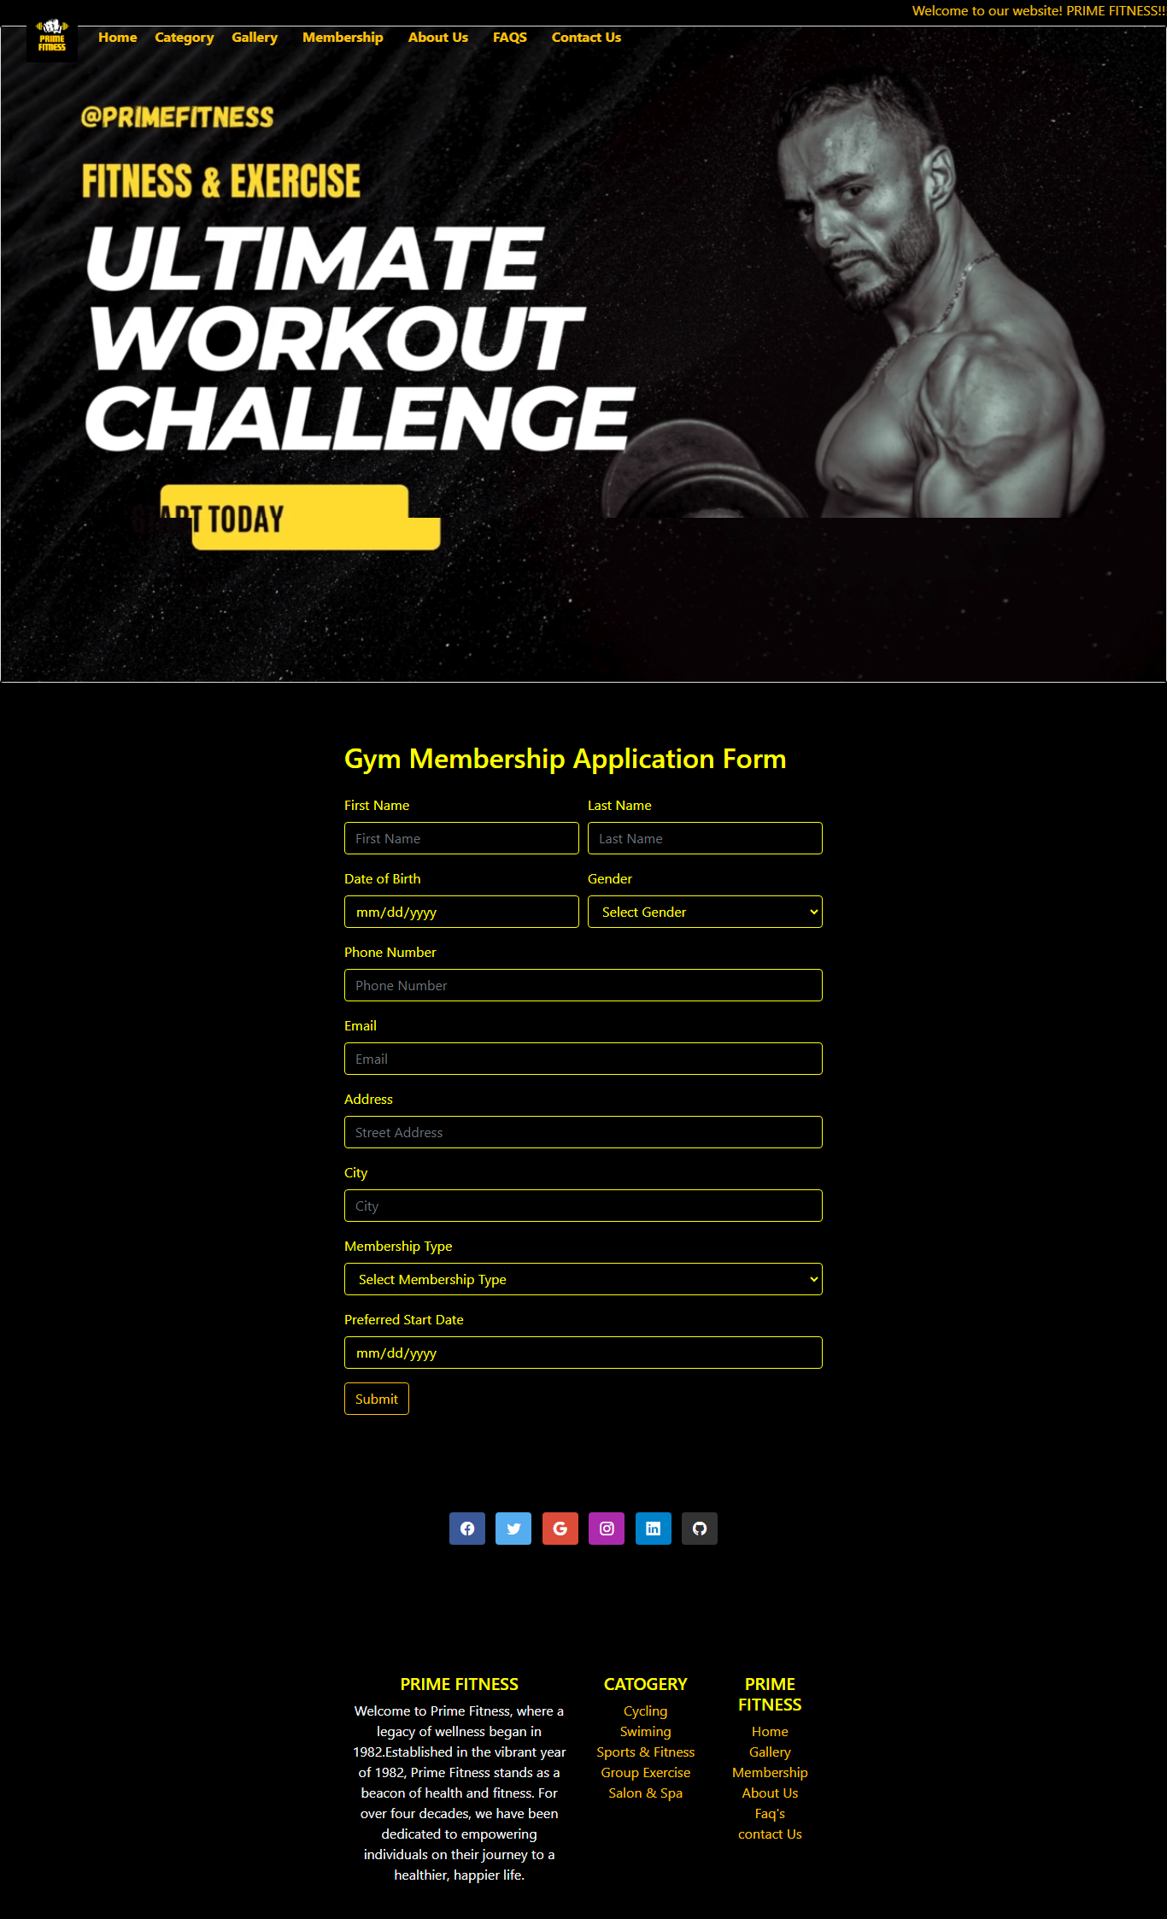

<!DOCTYPE html>

<html lang="en">

<head>

    <meta charset="UTF-8">

    <meta name="viewport" content="width=device-width, initial-scale=1, shrink-to-fit=no">

    <link href="https://stackpath.bootstrapcdn.com/bootstrap/4.3.1/css/bootstrap.min.css" rel="stylesheet">

         <!-- icon CDN -->

  <link rel="stylesheet" href="https://cdn.jsdelivr.net/npm/bootstrap-icons@1.11.3/font/bootstrap-icons.min.css">

  <!-- Icon ENd -->

    <title>Gym Membership Form</title>

    <style>

        body {

            background-color: black;

            color: yellow;

        }

        .container {

            max-width: 600px;

            background-color: black;

            color: yellow;

            padding: 20px;

            border-radius: 10px;

            box-shadow: 0 0 10px rgba(0, 0, 0, 0.3);

            margin-top: 50px;

        }

        .form-control {

            background-color: black;

            color: yellow;

            border: 1px solid yellow;

        }

        label {

            color: yellow;

        }

        select {

            background-color: black;

            color: yellow;

            border: 1px solid yellow;

        }

        /* .btn-primary {

            background-color: yellow;

            color: black;

            border: 1px solid yellow;

        } */

        /* Additional styling to remove button-like appearance */

        .custom-dropdown {

            display: inline-block;

            position: relative;

            cursor: pointer;

        }

        .dropdown-menu {

            position: absolute;

            top: 100%;

            left: 0;

            z-index: 1000;

            display: none;

            float: left;

            min-width: 10rem;

            padding: .5rem 0;

            margin: .125rem 0 0;

            font-size: 1rem;

            color: #212529;

            text-align: left;

            list-style: none;

            background-color: #fff;

            background-clip: padding-box;

            border: 1px solid rgba(0, 0, 0, .15);

            border-radius: .25rem;

        }

        .custom-dropdown:hover .dropdown-menu {

            display: block;

        }

        .custom-dropdown {

            padding-top: 7.5px;

        }

        li {

            background-color: black;

        }

        .outlined-text {

            color: yellow;

            text-shadow:

                -1px -1px 0 #000,

                1px -1px 0 #000,

                -1px 1px 0 #000,

                1px 1px 0 #000;

        }

    </style>

</head>

<body>

   <marquee class="text-warning"  behavior="scroll" direction="left">

  Welcome to our website! PRIME FITNESS!!!...Your Path to a Healthier.Monday - Friday: 6:00 AM - 10:00 PM.... Saturday: 8:00 AM - 8:00 PM....Sunday: Closed

</marquee>

    <!-- Nav Start -->

    <nav class="navbar navbar-expand-lg fixed-top ">

        <div class="container-fluid">

            <a class="navbar-brand" href="index.html">

                <img src="IMAGES/P1.png" alt="" height="60px">

            </a>

            <button class="navbar-toggler" type="button" data-bs-toggle="collapse" data-bs-target="#navbarNavAltMarkup"

                aria-controls="navbarNavAltMarkup" aria-expanded="false" aria-label="Toggle navigation">

                <span class="navbar-toggler-icon " style="background-color: #f0ec08;"></span>

            </button>

            <div class="collapse navbar-collapse" id="navbarNavAltMarkup">

                <div class="navbar-nav">

                    <a class="nav-link active text-warning" href="index.html"><b>Home</b></a>

                    &nbsp;

                    &nbsp;

                    <div class="custom-dropdown ">

                        <span class="text-warning"><b>Category</b></span>

                        <ul class="dropdown-menu text-bg-dark">

                            <li><a class="dropdown-item text-bg-dark text-warning"

                                    href=catogary\cycling.html>Cycling</a></li>

                            <li><a class="dropdown-item text-bg-dark text-warning" href="catogary\swim.html">Swiming</a>

                            </li>

                            <li><a class="dropdown-item text-bg-dark text-warning" href="Sports & Fitness.html">Sports &

                                    Fitness</a>

                            </li>

                            <li><a class="dropdown-item text-bg-dark text-warning"

                                    href="catogary\group exercise.html">Group Exercise</a></li>

                            <li><a class="dropdown-item text-bg-dark text-warning"

                                    href="catogary\salon and spa.html">Salon & Spa</a></li>

                        </ul>

                    </div>

                    &nbsp;

                    &nbsp;

                    <a class="nav-link active text-warning" href="Gallery/gallery.html"><b>Gallery</b></a>

                    &nbsp;

                    &nbsp;

                    <a class="nav-link active text-warning" href="membership.html"><b>Membership</b></a>

                    &nbsp;

                    &nbsp;

                    <a class="nav-link active text-warning" href="about us/about us.html"><b>About Us</b></a>

                    &nbsp;

                    &nbsp;

                    <a class="nav-link active text-warning" href="faq.html"><b>FAQS</b></a>

                    &nbsp;

                    &nbsp;

                    <a class="nav-link active text-warning" href="contact us .html"><b>Contact Us</b></a>

                </div>

            </div>

        </div>

    </nav>

    <!-- Nav End -->

    <!-- Carousel Start -->

    <div class="card" style="width: 100%px;">

        <video loop autoplay loop muted loop>

            <source src="video/b7.mp4" type="video/mp4">

        </video>

    </div>

    <!-- Carousel End -->

    <div class="container mt-5">

        <form>

            <h2 class="mb-4">Gym Membership Application Form</h2>

            <!-- Personal Information -->

            <div class="form-row">

                <div class="form-group col-md-6">

                    <label for="firstName">First Name</label>

                    <input type="text" class="form-control" id="firstName" placeholder="First Name" required>

                </div>

                <div class="form-group col-md-6">

                    <label for="lastName">Last Name</label>

                    <input type="text" class="form-control" id="lastName" placeholder="Last Name" required>

                </div>

            </div>

            <div class="form-row">

                <div class="form-group col-md-6">

                    <label for="dob">Date of Birth</label>

                    <input type="date" class="form-control" id="dob" placeholder="MM/DD/YYYY" required>

                </div>

                <div class="form-group col-md-6">

                    <label>Gender</label>

                    <select class="form-control" id="gender" required>

                        <option value="" selected disabled>Select Gender</option>

                        <option value="male">Male</option>

                        <option value="female">Female</option>

                        <option value="other">Other</option>

                    </select>

                </div>

            </div>

            <!-- Contact Information -->

            <div class="form-group">

                <label for="phoneNumber">Phone Number</label>

                <input type="tel" class="form-control" id="phoneNumber" placeholder="Phone Number" required>

            </div>

            <div class="form-group">

                <label for="email">Email</label>

                <input type="email" class="form-control" id="email" placeholder="Email" required>

            </div>

            <!-- Address -->

            <div class="form-group">

                <label for="address">Address</label>

                <input type="text" class="form-control" id="address" placeholder="Street Address" required>

            </div>

                <div class="form-group ">

                    <label for="city">City</label>

                    <input type="text" class="form-control" id="city" placeholder="City" required>

                </div>

            <!-- Membership Details -->

            <div class="form-group">

                <label for="membershipType">Membership Type</label>

                <select class="form-control" id="membershipType" required>

                    <option value="" selected disabled>Select Membership Type</option>

                    <option value="monthly">Monthly</option>

                    <option value="quarterly">Quarterly</option>

                    <option value="annual">Annual</option>

                </select>

            </div>

            <div class="form-group">

                <label for="startDate">Preferred Start Date</label>

                <input type="date" class="form-control" id="startDate" placeholder="MM/DD/YYYY" required>

            </div>

            <div class="form-group">

                <button type="submit" class="btn btn-outline-warning">Submit</button>

            </div>

        </form>

    </div>

     <!-- footer stART  -->

  <footer class=" text-center" style="background-color: #000;">

    <!-- Grid container -->

    <div class="container p-4 pb-0">

      <!-- Section: Social media -->

      <section class="mb-4 pb-4">

        <!-- Facebook -->

        <a data-mdb-ripple-init class="btn text-white btn-floating m-1" style="background-color: #3b5998;" href="https://www.facebook.com/atmospherefitnesspk/" target="_blank"

          role="button"><i class="bi bi-facebook"></i></a>

        <!-- Twitter -->

        <a data-mdb-ripple-init class="btn text-white btn-floating m-1" style="background-color: #55acee;" href="https://twitter.com/GymBodyFitness_" target="_blank"

          role="button"><i class="bi bi-twitter"></i></a>

        <!-- Google -->

        <a data-mdb-ripple-init class="btn text-white btn-floating m-1" style="background-color: #dd4b39;" href="https://www.google.com/webhp?hl=en&sa=X&ved=0ahUKEwjsofiW5cuEAxUv_bsIHWLMDtoQPAgJ" target="_blank"

          role="button"><i class="bi bi-google"></i></a>

        <!-- Instagram -->

        <a data-mdb-ripple-init class="btn text-white btn-floating m-1" style="background-color: #ac2bac;" href="https://www.instagram.com/primefitnesspakistan/" target="_blank"

          role="button"><i class="bi bi-instagram"></i></a>

        <!-- Linkedin -->

        <a data-mdb-ripple-init class="btn text-white btn-floating m-1" style="background-color: #0082ca;" href="https://www.linkedin.com/login" target="_blank"

          role="button"><i class="bi bi-linkedin"></i></a>

        <!-- Github -->

        <a data-mdb-ripple-init class="btn text-white btn-floating m-1" style="background-color: #333333;" href="https://github.com/login" target="_blank"

          role="button"><i class="bi bi-github"></i></a>

      </section>

      <!-- Section: Social media -->

    </div>

    <!-- Grid container -->

  </footer>

  <!-- second footer -->

  <section class="">

    <!-- Footer -->

    <footer class=" text-center" style="background-color: #000;">

      <!-- Grid container -->

      <div class="container p-4">

        <!--Grid row-->

        <div class="row">

          <!--Grid column-->

          <div class="col-lg-6 col-md-12 mb-4 mb-md-0">

            <h5 class="text-uppercase outlined-text">Prime Fitness</h5>

            <p class="text-light">

              Welcome to Prime Fitness, where a legacy of wellness began in 1982.Established in the vibrant year of

              1982, Prime Fitness stands as a beacon of health and fitness. For over four decades, we have been

              dedicated to empowering individuals on their journey to a healthier, happier life.

            </p>

          </div>

          <!--Grid column-->

          <!--Grid column-->

          <div class="col-lg-3 col-md-6 mb-4 mb-md-0">

            <h5 class="text-uppercase outlined-text">Catogery</h5>

            <ul class="list-unstyled mb-0">

              <li>

                <a href="catogary/cycling.html" class="text-warning">Cycling</a>

              </li>

              <li>

                <a href="catogary/swim.html" class="text-warning">Swiming</a>

              </li>

              <li>

                <a href="Sports & Fitness.html" class="text-warning">Sports & Fitness</a>

              </li>

              <li>

                <a href="catogary/group exercise.html" class="text-warning">Group Exercise</a>

              </li>

              <li>

                <a href="catogary/salon and spa.html" class="text-warning">Salon & Spa</a>

              </li>

            </ul>

          </div>

          <!--Grid column-->

          <!--Grid column-->

          <div class="col-lg-3 col-md-6 mb-4 mb-md-0">

            <h5 class="text-uppercase outlined-text">Prime Fitness</h5>

            <ul class="list-unstyled">

              <li>

                <a href="index.html" class="text-warning">Home</a>

              </li>

              <li>

                <a href="Gallery/gallery.html" class="text-warning">Gallery</a>

              </li>

              <li>

                <a href="membership.html" class="text-warning">Membership </a>

              </li>

              <li>

                <a href="about us/about us.html" class="text-warning">About Us</a>

              </li>

              <li>

                <a href="faq.html" class="text-warning">Faq's</a>

              </li>

              <li>

                <a href="contact us .html" class="text-warning">contact Us</a>

              </li>

            </ul>

          </div>

          <!--Grid column-->

        </div>

        <!--Grid row-->

      </div>

      <!-- Grid container -->

      <!-- Copyright -->

      <!-- <div class="text-center p-3" style="background-color: rgba(0, 0, 0, 0.05);">

        © 2020 Copyright:

        <a class="text-body" href="https://mdbootstrap.com/">MDBootstrap.com</a>

      </div> -->

      <!-- Copyright -->

    </footer>

    <!-- Footer -->

  </section>

  <!-- footer end  -->

    <script src="https://code.jquery.com/jquery-3.3.1.slim.min.js"></script>

    <script src="https://cdnjs.cloudflare.com/ajax/libs/popper.js/1.14.7/umd/popper.min.js"></script>

    <script src="https://stackpath.bootstrapcdn.com/bootstrap/4.3.1/js/bootstrap.min.js"></script>

</body>

</html>

ABOUT US :

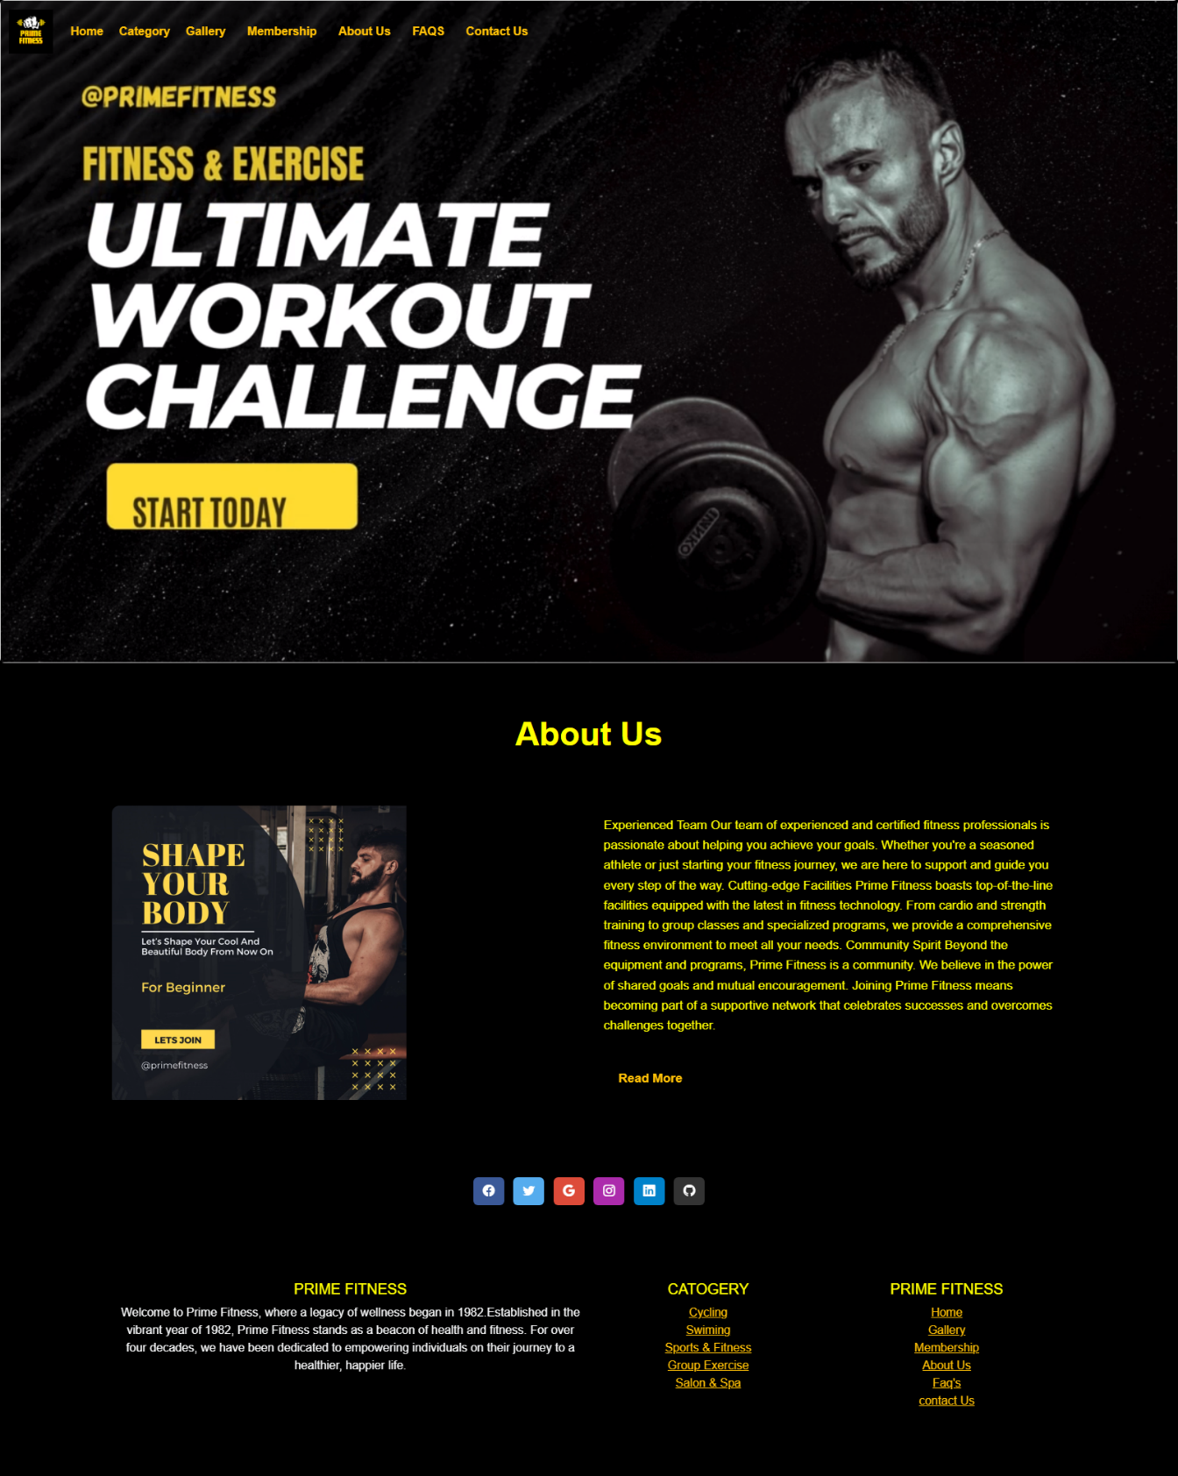

<!DOCTYPE html>

<html lang="en">

<head>

    <meta charset="UTF-8">

    <meta name="viewport" content="width=, initial-scale=1.0">

    <title>Home|About Us</title>

    <link rel="stylesheet" href="style.css">

    <!-- CDN start -->

    <link href="https://cdn.jsdelivr.net/npm/bootstrap@5.3.2/dist/css/bootstrap.min.css" rel="stylesheet"

        integrity="sha384-T3c6CoIi6uLrA9TneNEoa7RxnatzjcDSCmG1MXxSR1GAsXEV/Dwwykc2MPK8M2HN" crossorigin="anonymous">

    <script src="https://cdn.jsdelivr.net/npm/bootstrap@5.3.2/dist/js/bootstrap.bundle.min.js"

        integrity="sha384-C6RzsynM9kWDrMNeT87bh95OGNyZPhcTNXj1NW7RuBCsyN/o0jlpcV8Qyq46cDfL"

        crossorigin="anonymous"></script>

    <!-- CDN end -->

    <!-- icon CDN -->

    <link rel="stylesheet" href="https://cdn.jsdelivr.net/npm/bootstrap-icons@1.11.3/font/bootstrap-icons.min.css">

    <!-- Icon ENd -->

    <style>

        h1 {

            text-align: center;

            text-align: justify;

        }

        .outlined-text {

            color: yellow;

            text-shadow:

                -1px -1px 0 #000,

                1px -1px 0 #000,

                -1px 1px 0 #000,

                1px 1px 0 #000;

        }

        body {

            background-color: #000;

        }

        /* Additional styling to remove button-like appearance */

        .custom-dropdown {

            display: inline-block;

            position: relative;

            cursor: pointer;

        }

        .dropdown-menu {

            position: absolute;

            top: 100%;

            left: 0;

            z-index: 1000;

            display: none;

            float: left;

            min-width: 10rem;

            padding: .5rem 0;

            margin: .125rem 0 0;

            font-size: 1rem;

            color: #212529;

            text-align: left;

            list-style: none;

            background-color: #fff;

            background-clip: padding-box;

            border: 1px solid rgba(0, 0, 0, .15);

            border-radius: .25rem;

        }

        .custom-dropdown:hover .dropdown-menu {

            display: block;

        }

        .custom-dropdown {

            padding-top: 7.5px;

        }

        li {

            background-color: black;

        }

    </style>

</head>

<body>

  <marquee class="text-warning"  behavior="scroll" direction="left">

    Welcome to our website! PRIME FITNESS!!!...Your Path to a Healthier.Monday - Friday: 6:00 AM - 10:00 PM.... Saturday: 8:00 AM - 8:00 PM....Sunday: Closed

</marquee>

    <!-- Nav Start -->

    <nav class="navbar navbar-expand-lg fixed-top ">

        <div class="container-fluid">

            <a class="navbar-brand" href="index.html">

                <img src="../IMAGES/P1.png" alt="" height="60px">

            </a>

            <button class="navbar-toggler" type="button" data-bs-toggle="collapse" data-bs-target="#navbarNavAltMarkup"

                aria-controls="navbarNavAltMarkup" aria-expanded="false" aria-label="Toggle navigation">

                <span class="navbar-toggler-icon " style="background-color: #f0ec08;"></span>

            </button>

            <div class="collapse navbar-collapse" id="navbarNavAltMarkup">

                <div class="navbar-nav">

                    <a class="nav-link active text-warning" href="../index.html"><b>Home</b></a>

                    &nbsp;

                    &nbsp;

                    <div class="custom-dropdown ">

                        <span class="text-warning"><b>Category</b></span>

                        <ul class="dropdown-menu text-bg-dark">

                            <li><a class="dropdown-item text-bg-dark text-warning" href="../catogary/cycling.html">Cycling</a></li>

                            <li><a class="dropdown-item text-bg-dark text-warning" href="../catogary/swim.html">Swiming</a></li>

                            <li><a class="dropdown-item text-bg-dark text-warning"

                                    href="../Sports & Fitness.html">Sports & Fitness</a>

                            </li>

                            <li><a class="dropdown-item text-bg-dark text-warning" href="../catogary/group exercise.html">Group Exercise</a></li>

                            <li><a class="dropdown-item text-bg-dark text-warning" href="../catogary/salon and spa.html">Salon & Spa</a></li>

                        </ul>

                    </div>

                    &nbsp;

                    &nbsp;

                    <a class="nav-link active text-warning" href="../Gallery/gallery.html"><b>Gallery</b></a>

                    &nbsp;

                    &nbsp;

                    <a class="nav-link active text-warning" href="../membership.html"><b>Membership</b></a>

                    &nbsp;

                    &nbsp;

                    <a class="nav-link active text-warning" href="../about us/about us.html"><b>About Us</b></a>

                    &nbsp;

                    &nbsp;

                    <a class="nav-link active text-warning" href="../faq.html"><b>FAQS</b></a>

                    &nbsp;

                    &nbsp;

                    <a class="nav-link active text-warning" href="../contact us .html"><b>Contact Us</b></a>

                </div>

            </div>

        </div>

    </nav>

    <!-- Nav End -->

    <!-- Carousel Start -->

    <div class="card" style="width: 100%px;">

        <video loop autoplay loop muted loop>

            <source src="../video/b7.mp4" type="video/mp4">

        </video>

    </div>

    <!-- Carousel End -->

    <!-- abbout us Start -->

    <div class="container">

        <h1 class="title outlined-text">About Us</h1>

        <div class="about-content">

            <div class="image">

                <video loop autoplay loop muted loop width="400px">

                    <source src="b1.mp4" type="video/mp4">

                </video>

            </div>

            <div class="content">

                <p>Experienced Team

                    Our team of experienced and certified fitness professionals is passionate about helping you achieve

                    your goals. Whether you're a seasoned athlete or just starting your fitness journey, we are here to

                    support and guide you every step of the way.

                    Cutting-edge Facilities

                    Prime Fitness boasts top-of-the-line facilities equipped with the latest in fitness technology. From

                    cardio and strength training to group classes and specialized programs, we provide a comprehensive

                    fitness environment to meet all your needs.

                    Community Spirit

                    Beyond the equipment and programs, Prime Fitness is a community. We believe in the power of shared

                    goals and mutual encouragement. Joining Prime Fitness means becoming part of a supportive network

                    that celebrates successes and overcomes challenges together.

                </p>

                <a href="Readmore.html" class="readmore text-warning">Read More</a>

            </div>

        </div>

    </div>

    <!-- about us end -->

    <!-- footer stART  -->

  <footer class=" text-center" style="background-color: #000;">

    <!-- Grid container -->

    <div class="container p-4 pb-0">

      <!-- Section: Social media -->

      <section class="mb-4 pb-4">

        <!-- Facebook -->

        <a data-mdb-ripple-init class="btn text-white btn-floating m-1" style="background-color: #3b5998;" href="https://www.facebook.com/atmospherefitnesspk/" target="_blank"

          role="button"><i class="bi bi-facebook"></i></a>

        <!-- Twitter -->

        <a data-mdb-ripple-init class="btn text-white btn-floating m-1" style="background-color: #55acee;" href="https://twitter.com/GymBodyFitness_" target="_blank"

          role="button"><i class="bi bi-twitter"></i></a>

        <!-- Google -->

        <a data-mdb-ripple-init class="btn text-white btn-floating m-1" style="background-color: #dd4b39;" href="https://www.google.com/webhp?hl=en&sa=X&ved=0ahUKEwjsofiW5cuEAxUv_bsIHWLMDtoQPAgJ" target="_blank"

          role="button"><i class="bi bi-google"></i></a>

        <!-- Instagram -->

        <a data-mdb-ripple-init class="btn text-white btn-floating m-1" style="background-color: #ac2bac;" href="https://www.instagram.com/primefitnesspakistan/" target="_blank"

          role="button"><i class="bi bi-instagram"></i></a>

        <!-- Linkedin -->

        <a data-mdb-ripple-init class="btn text-white btn-floating m-1" style="background-color: #0082ca;" href="https://www.linkedin.com/login" target="_blank"

          role="button"><i class="bi bi-linkedin"></i></a>

        <!-- Github -->

        <a data-mdb-ripple-init class="btn text-white btn-floating m-1" style="background-color: #333333;" href="https://github.com/login" target="_blank"

          role="button"><i class="bi bi-github"></i></a>

      </section>

      <!-- Section: Social media -->

    </div>

    <!-- Grid container -->

  </footer>

  <!-- second footer -->

  <section class="">

    <!-- Footer -->

    <footer class=" text-center" style="background-color: #000;">

      <!-- Grid container -->

      <div class="container p-4">

        <!--Grid row-->

        <div class="row">

          <!--Grid column-->

          <div class="col-lg-6 col-md-12 mb-4 mb-md-0">

            <h5 class="text-uppercase outlined-text">Prime Fitness</h5>

            <p class="text-light">

              Welcome to Prime Fitness, where a legacy of wellness began in 1982.Established in the vibrant year of

              1982, Prime Fitness stands as a beacon of health and fitness. For over four decades, we have been

              dedicated to empowering individuals on their journey to a healthier, happier life.

            </p>

          </div>

          <!--Grid column-->

          <!--Grid column-->

          <div class="col-lg-3 col-md-6 mb-4 mb-md-0">

            <h5 class="text-uppercase outlined-text">Catogery</h5>

            <ul class="list-unstyled mb-0">

              <li>

                <a href="../catogary/cycling.html" class="text-warning">Cycling</a>

              </li>

              <li>

                <a href="../catogary/swim.html" class="text-warning">Swiming</a>

              </li>

              <li>

                <a href="../Sports & Fitness.html & Fitness.html" class="text-warning">Sports & Fitness</a>

              </li>

              <li>

                <a href="../catogary/group exercise.html " class="text-warning">Group Exercise</a>

              </li>

              <li>

                <a href="../catogary/salon and spa.html" class="text-warning">Salon & Spa</a>

              </li>

            </ul>

          </div>

          <!--Grid column-->

          <!--Grid column-->

          <div class="col-lg-3 col-md-6 mb-4 mb-md-0">

            <h5 class="text-uppercase outlined-text">Prime Fitness</h5>

            <ul class="list-unstyled">

              <li>

                <a href="../index.html" class="text-warning">Home</a>

              </li>

              <li>

                <a href="../Gallery/gallery.html" class="text-warning">Gallery</a>

              </li>

              <li>

                <a href="../membership.html" class="text-warning">Membership </a>

              </li>

              <li>

                <a href="../about us/about us.html " class="text-warning">About Us</a>

              </li>

              <li>

                <a href="../faq.html" class="text-warning">Faq's</a>

              </li>

              <li>

                <a href="../contact us .html us .html" class="text-warning">contact Us</a>

              </li>

            </ul>

          </div>

          <!--Grid column-->

        </div>

        <!--Grid row-->

      </div>

      <!-- Grid container -->

      <!-- Copyright -->

      <!-- <div class="text-center p-3" style="background-color: rgba(0, 0, 0, 0.05);">

        © 2020 Copyright:

        <a class="text-body" href="https://mdbootstrap.com/">MDBootstrap.com</a>

      </div> -->

      <!-- Copyright -->

    </footer>

    <!-- Footer -->

  </section>

  <!-- footer end  -->

</body>

</html>

FAQ’S:

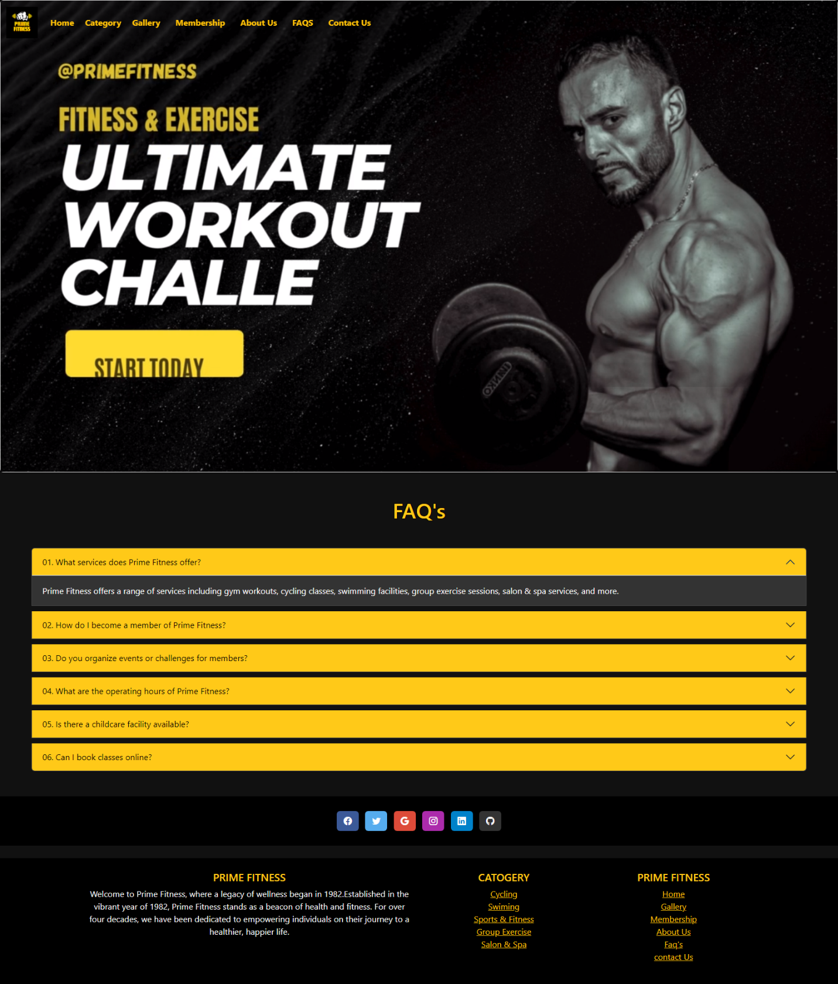

<!DOCTYPE html>

<html lang="en">

<head>

    <meta charset="UTF-8">

    <meta name="viewport" content="width=device-width, initial-scale=1.0">

    <title>Document</title>

    <!-- CDN start -->

    <link href="https://cdn.jsdelivr.net/npm/bootstrap@5.3.2/dist/css/bootstrap.min.css" rel="stylesheet"

        integrity="sha384-T3c6CoIi6uLrA9TneNEoa7RxnatzjcDSCmG1MXxSR1GAsXEV/Dwwykc2MPK8M2HN" crossorigin="anonymous">

    <script src="https://cdn.jsdelivr.net/npm/bootstrap@5.3.2/dist/js/bootstrap.bundle.min.js"

        integrity="sha384-C6RzsynM9kWDrMNeT87bh95OGNyZPhcTNXj1NW7RuBCsyN/o0jlpcV8Qyq46cDfL"

        crossorigin="anonymous"></script>

    <!-- CDN end -->

    <!-- icon CDN -->

    <link rel="stylesheet" href="https://cdn.jsdelivr.net/npm/bootstrap-icons@1.11.3/font/bootstrap-icons.min.css">

    <!-- Icon ENd -->

    <style>

        p {

            color: rgb(250, 250, 244);

        }

        body {

            background-color: black;

        }

        /* Additional styling to remove button-like appearance */

        .custom-dropdown {

            display: inline-block;

            position: relative;

            cursor: pointer;

        }

        .dropdown-menu {

            position: absolute;

            top: 100%;

            left: 0;

            z-index: 1000;

            display: none;

            float: left;

            min-width: 10rem;

            padding: .5rem 0;

            margin: .125rem 0 0;

            font-size: 1rem;

            color: #212529;

            text-align: left;

            list-style: none;

            background-color: #fff;

            background-clip: padding-box;

            border: 1px solid rgba(0, 0, 0, .15);

            border-radius: .25rem;

        }

        .custom-dropdown:hover .dropdown-menu {

            display: block;

        }

        .custom-dropdown {

            padding-top: 7.5px;

        }

        li {

            background-color: black;

        }

        .outlined-text {

            color:rgb(255, 201, 24);;

            text-shadow:

                -1px -1px 0 #000,

                1px -1px 0 #000,

                -1px 1px 0 #000,

                1px 1px 0 #000;

        }

        body {

            background-color: #111;

            /* Set background color to black */

            color: #fff;

            /* Set text color to white */

        }

        .accordion-button {

            background-color: #333;

            /* Set accordion button background color to dark gray */

            color: #fff;

            /* Set accordion button text color to white */

        }

        .accordion-button:hover {

            background-color: #555;

            /* Set accordion button background color on hover */

        }

        .accordion-item {

            background-color: #222;

            /* Set accordion item background color to a darker shade of gray */

            border: 1px solid #444;

            /* Set accordion item border color */

            margin-bottom: 10px;

            /* Add some space between accordion items */

        }

        .accordion-body {

            background-color: #333;

            /* Set accordion body background color */

            color: #fff;

            /* Set accordion body text color to white */

            border-top: 1px solid #444;

            /* Set border color for the top of accordion body */

        }

        #bg {

            background-color: rgb(255, 201, 24);

            color: rgb(0, 0, 0);

        }

    </style>

</head>

<body>

  <marquee class="text-warning"  behavior="scroll" direction="left">

    Welcome to our website! PRIME FITNESS!!!...Your Path to a Healthier.Monday - Friday: 6:00 AM - 10:00 PM.... Saturday: 8:00 AM - 8:00 PM....Sunday: Closed

</marquee>

    <!-- Nav Start -->

  <nav class="navbar navbar-expand-lg fixed-top ">

    <div class="container-fluid">

      <a class="navbar-brand" href="index.html">

        <img src="IMAGES/P1.png" alt="" height="60px">

      </a>

      <button class="navbar-toggler" type="button" data-bs-toggle="collapse" data-bs-target="#navbarNavAltMarkup"

        aria-controls="navbarNavAltMarkup" aria-expanded="false" aria-label="Toggle navigation">

        <span class="navbar-toggler-icon " style="background-color: #f0ec08;"></span>

      </button>

      <div class="collapse navbar-collapse" id="navbarNavAltMarkup">

        <div class="navbar-nav">

          <a class="nav-link active text-warning" href="index.html"><b>Home</b></a>

          &nbsp;

          &nbsp;

          <div class="custom-dropdown ">

            <span class="text-warning"><b>Category</b></span>

            <ul class="dropdown-menu text-bg-dark">

              <li><a class="dropdown-item text-bg-dark text-warning" href=catogary\cycling.html>Cycling</a></li>

              <li><a class="dropdown-item text-bg-dark text-warning" href="catogary\swim.html">Swiming</a></li>

              <li><a class="dropdown-item text-bg-dark text-warning" href="Sports & Fitness.html">Sports & Fitness</a>

              </li>

              <li><a class="dropdown-item text-bg-dark text-warning" href="catogary\group exercise.html">Group Exercise</a></li>

              <li><a class="dropdown-item text-bg-dark text-warning" href="catogary\salon and spa.html">Salon & Spa</a></li>

            </ul>

          </div>

          &nbsp;

          &nbsp;

          <a class="nav-link active text-warning" href="Gallery/gallery.html"><b>Gallery</b></a>

          &nbsp;

          &nbsp;

          <a class="nav-link active text-warning" href="membership.html"><b>Membership</b></a>

          &nbsp;

          &nbsp;

          <a class="nav-link active text-warning" href="about us/about us.html"><b>About Us</b></a>

          &nbsp;

          &nbsp;

          <a class="nav-link active text-warning" href="faq.html"><b>FAQS</b></a>

          &nbsp;

          &nbsp;

          <a class="nav-link active text-warning" href="contact us .html"><b>Contact Us</b></a>

        </div>

      </div>

    </div>

  </nav>

  <!-- Nav End -->

    <!-- Carousel Start -->

    <div class="card" style="width: 100%px;">

        <video loop autoplay loop muted loop>

            <source src="video/b7.mp4" type="video/mp4">

        </video>

    </div>

    <!-- Carousel End -->

    <div class="container-fluid mt-5 mb-5">

        <h1 class="outlined-text mt-5 mb-5" style="text-align: center;">FAQ's</h1>

        <div class="accordion mt-5 mx-5" id="accordionExample">

            <div class="accordion-item">

                <h2 class="accordion-header">

                    <button class="accordion-button " id="bg" type="button" data-bs-toggle="collapse"

                        data-bs-target="#collapseOne" aria-expanded="true" aria-controls="collapseOne">

                       01. What services does Prime Fitness offer?

                    </button>

                </h2>

                <div id="collapseOne" class="accordion-collapse collapse show" data-bs-parent="#accordionExample">

                    <div class="accordion-body">

                        <!-- <h4> <b><i>1. What services does Prime Fitness offer?</i> </b></h4><br> -->

                        Prime Fitness offers a range of services including gym workouts, cycling classes, swimming

                        facilities, group exercise sessions, salon & spa services, and more.

                    </div>

                </div>

            </div>

            <div class="accordion-item">

                <h2 class="accordion-header">

                    <button class="accordion-button collapsed" id="bg" type="button" data-bs-toggle="collapse"

                        data-bs-target="#collapseTwo" aria-expanded="false" aria-controls="collapseTwo">

                        02. How do I become a member of Prime Fitness?

                    </button>

                </h2>

                <div id="collapseTwo" class="accordion-collapse collapse" data-bs-parent="#accordionExample">

                    <div class="accordion-body">

                        To become a member, visit our Membership page on the website or visit our facility in person.

                        You can choose a membership plan that suits your needs.

                    </div>

                </div>

            </div>

            <div class="accordion-item">

                <h2 class="accordion-header">

                    <button class="accordion-button collapsed" id="bg" type="button" data-bs-toggle="collapse"

                        data-bs-target="#collapseThree" aria-expanded="false" aria-controls="collapseThree">

                        03. Do you organize events or challenges for members?

                    </button>

                </h2>

                <div id="collapseThree" class="accordion-collapse collapse" data-bs-parent="#accordionExample">

                    <div class="accordion-body">

                        Yes, Prime Fitness occasionally organizes events, challenges, and wellness programs for members. Stay updated through our website and social media for upcoming events.

                    </div>

                </div>

            </div>

            <div class="accordion-item">

                <h2 class="accordion-header">

                    <button class="accordion-button collapsed" id="bg" type="button" data-bs-toggle="collapse"

                        data-bs-target="#collapseThree" aria-expanded="false" aria-controls="collapseThree">

                        04. What are the operating hours of Prime Fitness?

                    </button>

                </h2>

                <div id="collapseThree" class="accordion-collapse collapse" data-bs-parent="#accordionExample">

                    <div class="accordion-body">

                        Our operating hours vary, and you can find the detailed schedule on our website or by contacting our front desk. We strive to accommodate various schedules for our members.

                    </div>

                </div>

            </div>

            <div class="accordion-item">

                <h2 class="accordion-header">

                    <button class="accordion-button collapsed" id="bg" type="button" data-bs-toggle="collapse"

                        data-bs-target="#collapseThree" aria-expanded="false" aria-controls="collapseThree">

                        05. Is there a childcare facility available?

                    </button>

                </h2>

                <div id="collapseThree" class="accordion-collapse collapse" data-bs-parent="#accordionExample">

                    <div class="accordion-body">

                        Prime Fitness understands the importance of childcare. Please check with our staff for information on childcare facilities and services.

                    </div>

                </div>

            </div>

            <div class="accordion-item">

                <h2 class="accordion-header">

                    <button class="accordion-button collapsed" id="bg" type="button" data-bs-toggle="collapse"

                        data-bs-target="#collapseThree" aria-expanded="false" aria-controls="collapseThree">

                06. Can I book classes online?

                    </button>

                </h2>

                <div id="collapseThree" class="accordion-collapse collapse" data-bs-parent="#accordionExample">

                    <div class="accordion-body">

                        Yes, you can typically book classes through our website or dedicated mobile app. Ensure you are registered as a member to access the booking features.

                    </div>

                </div>

            </div>

        </div>

    </div>

    <!-- footer stART  -->

  <footer class=" text-center" style="background-color: #000;">

    <!-- Grid container -->

    <div class="container p-4 pb-0">

      <!-- Section: Social media -->

      <section class="mb-4 pb-4">

        <!-- Facebook -->

        <a data-mdb-ripple-init class="btn text-white btn-floating m-1" style="background-color: #3b5998;" href="https://www.facebook.com/atmospherefitnesspk/" target="_blank"

          role="button"><i class="bi bi-facebook"></i></a>

        <!-- Twitter -->

        <a data-mdb-ripple-init class="btn text-white btn-floating m-1" style="background-color: #55acee;" href="https://twitter.com/GymBodyFitness_" target="_blank"

          role="button"><i class="bi bi-twitter"></i></a>

        <!-- Google -->

        <a data-mdb-ripple-init class="btn text-white btn-floating m-1" style="background-color: #dd4b39;" href="https://www.google.com/webhp?hl=en&sa=X&ved=0ahUKEwjsofiW5cuEAxUv_bsIHWLMDtoQPAgJ" target="_blank"

          role="button"><i class="bi bi-google"></i></a>

        <!-- Instagram -->

        <a data-mdb-ripple-init class="btn text-white btn-floating m-1" style="background-color: #ac2bac;" href="https://www.instagram.com/primefitnesspakistan/" target="_blank"

          role="button"><i class="bi bi-instagram"></i></a>

        <!-- Linkedin -->

        <a data-mdb-ripple-init class="btn text-white btn-floating m-1" style="background-color: #0082ca;" href="https://www.linkedin.com/login" target="_blank"

          role="button"><i class="bi bi-linkedin"></i></a>

        <!-- Github -->

        <a data-mdb-ripple-init class="btn text-white btn-floating m-1" style="background-color: #333333;" href="https://github.com/login" target="_blank"

          role="button"><i class="bi bi-github"></i></a>

      </section>

      <!-- Section: Social media -->

    </div>

    <!-- Grid container -->

  </footer>

  <!-- second footer -->

  <section class="">

    <!-- Footer -->

    <footer class=" text-center" style="background-color: #000;">

      <!-- Grid container -->

      <div class="container p-4">

        <!--Grid row-->

        <div class="row">

          <!--Grid column-->

          <div class="col-lg-6 col-md-12 mb-4 mb-md-0">

            <h5 class="text-uppercase outlined-text">Prime Fitness</h5>

            <p class="text-light">

              Welcome to Prime Fitness, where a legacy of wellness began in 1982.Established in the vibrant year of

              1982, Prime Fitness stands as a beacon of health and fitness. For over four decades, we have been

              dedicated to empowering individuals on their journey to a healthier, happier life.

            </p>

          </div>

          <!--Grid column-->

          <!--Grid column-->

          <div class="col-lg-3 col-md-6 mb-4 mb-md-0">

            <h5 class="text-uppercase outlined-text">Catogery</h5>

            <ul class="list-unstyled mb-0">

              <li>

                <a href="catogary/cycling.html" class="text-warning">Cycling</a>

              </li>

              <li>

                <a href="catogary/swim.html" class="text-warning">Swiming</a>

              </li>

              <li>

                <a href="Sports & Fitness.html" class="text-warning">Sports & Fitness</a>

              </li>

              <li>

                <a href="catogary/group exercise.html" class="text-warning">Group Exercise</a>

              </li>

              <li>

                <a href="catogary/salon and spa.html" class="text-warning">Salon & Spa</a>

              </li>

            </ul>

          </div>

          <!--Grid column-->

          <!--Grid column-->

          <div class="col-lg-3 col-md-6 mb-4 mb-md-0">

            <h5 class="text-uppercase outlined-text">Prime Fitness</h5>

            <ul class="list-unstyled">

              <li>

                <a href="index.html" class="text-warning">Home</a>

              </li>

              <li>

                <a href="Gallery/gallery.html" class="text-warning">Gallery</a>

              </li>

              <li>

                <a href="membership.html" class="text-warning">Membership </a>

              </li>

              <li>

                <a href="about us/about us.html" class="text-warning">About Us</a>

              </li>

              <li>

                <a href="faq.html" class="text-warning">Faq's</a>

              </li>

              <li>

                <a href="contact us .html" class="text-warning">contact Us</a>

              </li>

            </ul>

          </div>

          <!--Grid column-->

        </div>

        <!--Grid row-->

      </div>

      <!-- Grid container -->

      <!-- Copyright -->

      <!-- <div class="text-center p-3" style="background-color: rgba(0, 0, 0, 0.05);">

        © 2020 Copyright:

        <a class="text-body" href="https://mdbootstrap.com/">MDBootstrap.com</a>

      </div> -->

      <!-- Copyright -->

    </footer>

    <!-- Footer -->

  </section>

  <!-- footer end  -->

</body>

</html>

CONTACT US:

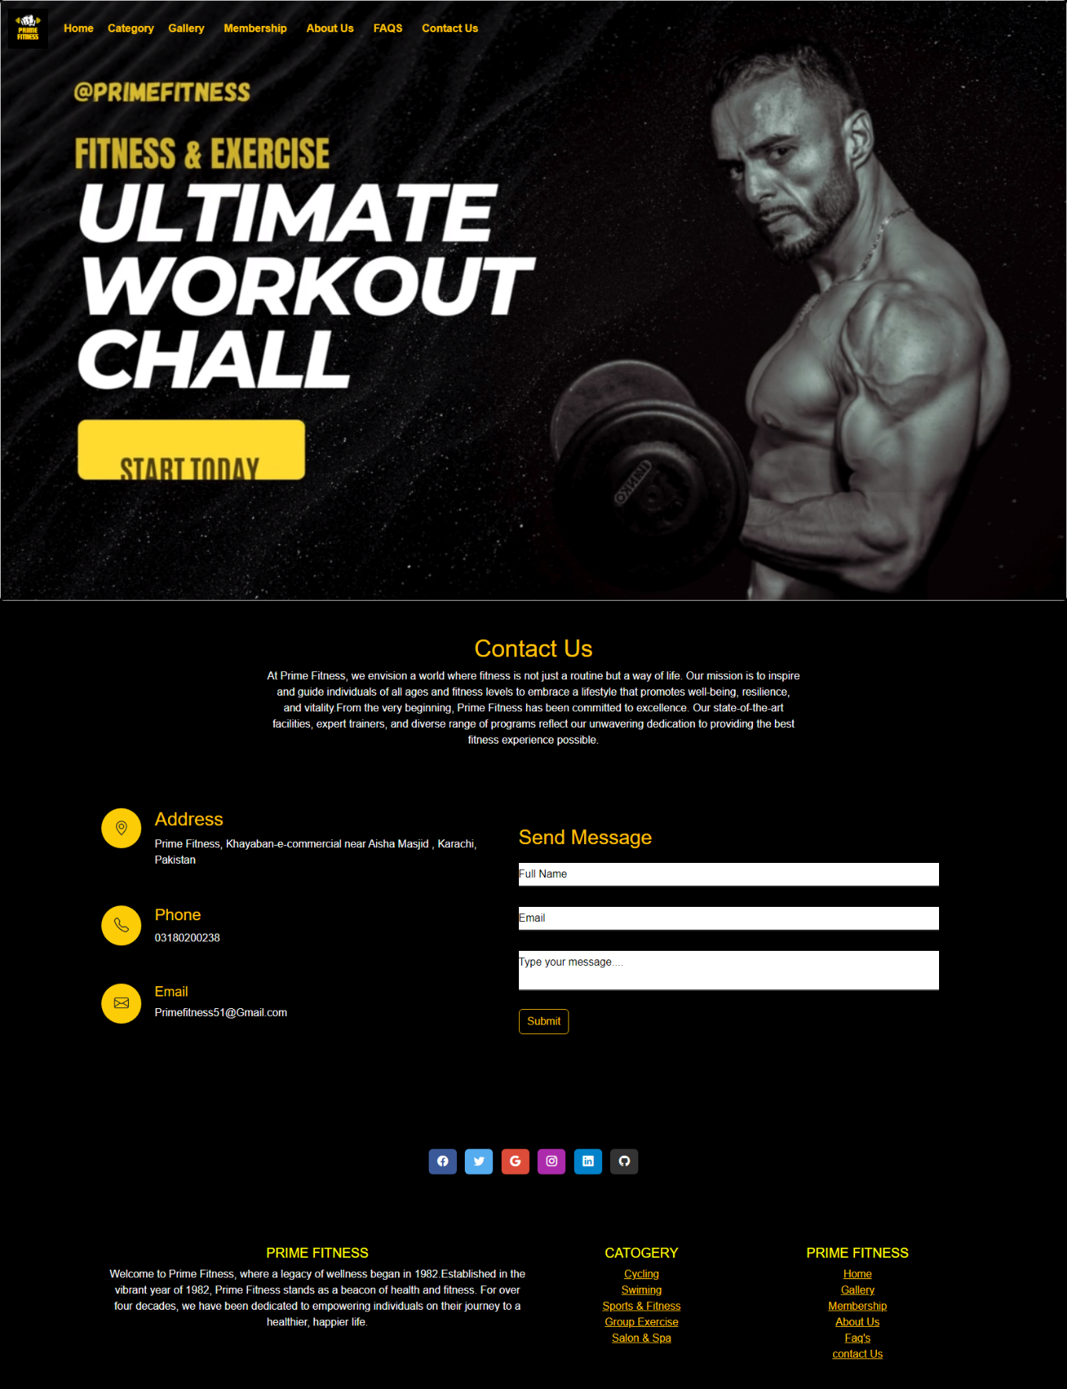

<!DOCTYPE html>

<html lang="en">

<head>

  <meta charset="UTF-8">

  <meta name="viewport" content="width=device-width, initial-scale=1.0">

  <title>Contact Us</title>

  <!-- Icon Link -->

  <link rel="shortcut icon" href="Image/logo.png">

  <!-- Bootstrap Stylesheet link -->

  <link rel="stylesheet" href="https://cdn.jsdelivr.net/npm/bootstrap@5.3.2/dist/css/bootstrap.min.css">

  <!-- external Css link -->

  <link rel="stylesheet" href="css/styl.css">

  <!-- bootstrap js link -->

  <script src="https://cdn.jsdelivr.net/npm/bootstrap@5.3.2/dist/js/bootstrap.bundle.min.js"></script>

  <!-- icon cdn strat  -->

  <link rel="stylesheet" href="https://cdn.jsdelivr.net/npm/bootstrap-icons@1.11.3/font/bootstrap-icons.min.css">

  <!-- icon cdn end  -->

  <style>

    * {

      margin: 0;

      padding: 0;

      box-sizing: border-box;

      font-family: 'Poppins', sans-serif;

    }

    .contact {

      position: relative;

      min-height: 100vh;

      padding: 50px 100px;

      display: flex;

      justify-content: center;

      align-items: center;

      flex-direction: column;

    }

    .contact .content {

      max-width: 800px;

      text-align: center;

    }

    .contact .content h2 {

      font-size: 36px;

      font-weight: 500;

      color: #fff;

    }

    .contact .content p {

      font-weight: 300;

      color: #fff;

    }

    .container {

      width: 100%;

      display: flex;

      justify-content: center;

      align-items: center;

      margin-top: 30px;

    }

    .container .contactInfo {

      width: 50%;

      display: flex;

      flex-direction: column;

    }

    .container .contactInfo .Box {

      padding: 20px 0;

      display: flex;

    }

    .container .contactInfo .Box .icon {

      min-width: 60px;

      height: 60px;

      background: #fccc07;

      display: flex;

      justify-content: center;

      align-items: center;

      border-radius: 50%;

      font-size: 22px;

    }

    .container .contactInfo .Box .text {

      margin-left: 20px;

      color: black;

    }

    .container .contactInfo .Box .text h3,

    .container .contactInfo .Box .text h4,

    .container .contactInfo .Box .text h5 {

      color: #333;

    }

    .contactForm {

      width: 60%;

      padding: 40px;

      background: #000000;

      margin-top: 30px;

    }

    .contactForm h2 {

      font-size: 30px;

      color: #333;

      font-weight: 500;

    }

    .contactForm .inputBox {

      position: relative;

      width: 100%;

      margin-top: 10px;

    }

    .contactForm .inputBox input,

    .contactForm .inputBox textarea {

      width: 100%;

      padding: 5px 0;

      font-size: 16px;

      margin: 10px 0;

      border: none;

      border-bottom: 2px solid #333;

      outline: none;

      resize: none;

    }

    .contactForm .inputBox span {

      position: absolute;

      left: 0;

      padding: 5px 0;

      font-size: 16px;

      margin: 10px 0;

      pointer-events: none;

      transition: 0.5s;

      color: #000000;

    }

    .contactForm .inputBox input:focus~span,

    .contactForm .inputBox input:valid~span,

    .contactForm .inputBox textarea:focus~span,

    .contactForm .inputBox textarea:valid~span {

      color: #fccc07;

      font-size: 12px;

      transform: translateY(-20px);

    }

    .contactForm .inputBox input[type="submit"] {

      width: 100px;

      background: #000000;

      color: #ffd900;

      border: none;

      cursor: pointer;

      padding: 10px;

      font-size: 18px;

    }

    @media (max-width:991px) {

      .contact {

        padding: 50px;

      }

      .container {

        flex-direction: column;

      }

      .container .contactInfo {

        margin-bottom: 40px;

      }

      .contactForm {

        width: 90%;

      }

    }

    .dropdown:hover {

      color: #fccc07;

    }

    .nave:hover {

      color: #fccc07;

    }

    #bgnavbar {

      background-color: skyblue;

    }

    .bg {

      background-image: url(bg-3.jpg);

      background-size: cover;

    }

    /* Additional styling to remove button-like appearance */

    .custom-dropdown {

      display: inline-block;

      position: relative;

      cursor: pointer;

    }

    .dropdown-menu {

      position: absolute;

      top: 100%;

      left: 0;

      z-index: 1000;

      display: none;

      float: left;

      min-width: 10rem;

      padding: .5rem 0;

      margin: .125rem 0 0;

      font-size: 1rem;

      color: #212529;

      text-align: left;

      list-style: none;

      background-color: #fff;

      background-clip: padding-box;

      border: 1px solid rgba(0, 0, 0, .15);

      border-radius: .25rem;

    }

    .custom-dropdown:hover .dropdown-menu {

      display: block;

    }

    .custom-dropdown {

      padding-top: 7.5px;

    }

    li {

      background-color: black;

    }

    .outlined-text {

      color: yellow;

      text-shadow:

        -1px -1px 0 #000,

        1px -1px 0 #000,

        -1px 1px 0 #000,

        1px 1px 0 #000;

    }

  </style>

</head>

<body class="bg-black">

  <marquee class="text-warning"  behavior="scroll" direction="left">

    Welcome to our website! PRIME FITNESS!!!...Your Path to a Healthier.Monday - Friday: 6:00 AM - 10:00 PM.... Saturday: 8:00 AM - 8:00 PM....Sunday: Closed

</marquee>

  <!-- Nav Start -->

  <nav class="navbar navbar-expand-lg fixed-top ">

    <div class="container-fluid">

      <a class="navbar-brand" href="index.html">

        <img src="IMAGES/P1.png" alt="" height="60px">

      </a>

      <button class="navbar-toggler" type="button" data-bs-toggle="collapse" data-bs-target="#navbarNavAltMarkup"

        aria-controls="navbarNavAltMarkup" aria-expanded="false" aria-label="Toggle navigation">

        <span class="navbar-toggler-icon " style="background-color: #f0ec08;"></span>

      </button>

      <div class="collapse navbar-collapse" id="navbarNavAltMarkup">

        <div class="navbar-nav">

          <a class="nav-link active text-warning" href="index.html"><b>Home</b></a>

          &nbsp;

          &nbsp;

          <div class="custom-dropdown ">

            <span class="text-warning"><b>Category</b></span>

            <ul class="dropdown-menu text-bg-dark">

              <li><a class="dropdown-item text-bg-dark text-warning" href=catogary\cycling.html>Cycling</a></li>

              <li><a class="dropdown-item text-bg-dark text-warning" href="catogary\swim.html">Swiming</a></li>

              <li><a class="dropdown-item text-bg-dark text-warning" href="Sports & Fitness.html">Sports & Fitness</a>

              </li>

              <li><a class="dropdown-item text-bg-dark text-warning" href="catogary\group exercise.html">Group

                  Exercise</a></li>

              <li><a class="dropdown-item text-bg-dark text-warning" href="catogary\salon and spa.html">Salon & Spa</a>

              </li>

            </ul>

          </div>

          &nbsp;

          &nbsp;

          <a class="nav-link active text-warning" href="Gallery/gallery.html"><b>Gallery</b></a>

          &nbsp;

          &nbsp;

          <a class="nav-link active text-warning" href="membership.html"><b>Membership</b></a>

          &nbsp;

          &nbsp;

          <a class="nav-link active text-warning" href="about us/about us.html"><b>About Us</b></a>

          &nbsp;

          &nbsp;

          <a class="nav-link active text-warning" href="faq.html"><b>FAQS</b></a>

          &nbsp;

          &nbsp;

          <a class="nav-link active text-warning" href="contact us .html"><b>Contact Us</b></a>

        </div>

      </div>

    </div>

  </nav>

  <!-- Nav End -->

  <!-- Carousel Start -->

  <div class="card" style="width: 100%px;">

    <video loop autoplay loop muted loop>

      <source src="video/b7.mp4" type="video/mp4">

    </video>

  </div>

  <!-- Carousel End -->

  <section class="contact">

    <div class="content">

      <h2 class="text-warning">Contact Us</h2>

      <p class="text-light">At Prime Fitness, we envision a world where fitness is not just a routine but a way of life.

        Our mission

        is to inspire and guide individuals of all ages and fitness levels to embrace a lifestyle that promotes

        well-being, resilience, and vitality.From the very beginning, Prime Fitness has been committed to

        excellence. Our state-of-the-art facilities, expert trainers, and diverse range of programs reflect our

        unwavering dedication to providing the best fitness experience possible.</p>

    </div>

    <div class="container">

      <div class="contactInfo">

        <div class="Box">

          <div class="icon"><i class="bi bi-geo-alt" aria-hidden="true"></i></div>

          <div class="text">

            <h3 class="text-warning">Address</h3>

            <p class="text-light">Prime Fitness, Khayaban-e-commercial near Aisha Masjid , Karachi, Pakistan</p>

          </div>

        </div>

        <div class="Box">

          <div class="icon"><i class="bi bi-telephone" aria-hidden="true"></i></div>

          <div class="text">

            <h4 class="text-warning">Phone</h4>

            <p class="text-light">03180200238</p>

          </div>

        </div>

        <div class="Box">

          <div class="icon"><i class="bi bi-envelope" aria-hidden="true"></i></div>

          <div class="text">

            <h5 class="text-warning">Email</h5>

            <p class="text-light">Primefitness51@Gmail.com</p>

          </div>

        </div>

      </div>

      <div class="contactForm">

        <form id="myForm">

          <h2 class="text-warning">Send Message</h2>

          <div class="inputBox">

              <input type="text" id="fullName" required="required">

              <span>Full Name</span>

          </div>

          <div class="inputBox">

              <input type="email" id="email" required="required">

              <span>Email</span>

          </div>

          <div class="inputBox">

              <textarea id="message" required="required"></textarea>

              <span>Type your message....</span>

          </div>

          <div class="inputBox hover">

              <button type="button" onclick="validateForm()" class="btn btn-outline-warning">Submit</button>

          </div>

      </form>

      <script>

        function validateForm() {

            var fullName = document.getElementById("fullName").value;

            var email = document.getElementById("email").value;

            var message = document.getElementById("message").value;

            if (fullName === "" || email === "" || message === "") {

                alert("Please fill in all fields");

            } else {

                // Validate Full Name: No digits allowed

                if (/[\d]/.test(fullName)) {

                    alert("Full Name should not contain digits");

                    return;

                }

                // Additional validation logic can be added here if needed

                // If the form is valid, display success alert

                alert("Form submitted successfully!");

                // You can choose to submit the form or perform other actions here

                document.getElementById("myForm").submit();

            }

        }

    </script>

      </div>

    </div>

  </section>

  <br>

   <!-- footer stART  -->

   <footer class=" text-center" style="background-color: #000;">

    <!-- Grid container -->

    <div class="container p-4 pb-0">

      <!-- Section: Social media -->

      <section class="mb-4 pb-4">

        <!-- Facebook -->

        <a data-mdb-ripple-init class="btn text-white btn-floating m-1" style="background-color: #3b5998;" href="https://www.facebook.com/atmospherefitnesspk/" target="_blank"

          role="button"><i class="bi bi-facebook"></i></a>

        <!-- Twitter -->

        <a data-mdb-ripple-init class="btn text-white btn-floating m-1" style="background-color: #55acee;" href="https://twitter.com/GymBodyFitness_" target="_blank"

          role="button"><i class="bi bi-twitter"></i></a>

        <!-- Google -->

        <a data-mdb-ripple-init class="btn text-white btn-floating m-1" style="background-color: #dd4b39;" href="https://www.google.com/webhp?hl=en&sa=X&ved=0ahUKEwjsofiW5cuEAxUv_bsIHWLMDtoQPAgJ" target="_blank"

          role="button"><i class="bi bi-google"></i></a>

        <!-- Instagram -->

        <a data-mdb-ripple-init class="btn text-white btn-floating m-1" style="background-color: #ac2bac;" href="https://www.instagram.com/primefitnesspakistan/" target="_blank"

          role="button"><i class="bi bi-instagram"></i></a>

        <!-- Linkedin -->

        <a data-mdb-ripple-init class="btn text-white btn-floating m-1" style="background-color: #0082ca;" href="https://www.linkedin.com/login" target="_blank"

          role="button"><i class="bi bi-linkedin"></i></a>

        <!-- Github -->

        <a data-mdb-ripple-init class="btn text-white btn-floating m-1" style="background-color: #333333;" href="https://github.com/login" target="_blank"

          role="button"><i class="bi bi-github"></i></a>

      </section>

      <!-- Section: Social media -->

    </div>

    <!-- Grid container -->

  </footer>

  <!-- second footer -->

  <section class="">

    <!-- Footer -->

    <footer class=" text-center" style="background-color: #000;">

      <!-- Grid container -->

      <div class="container p-4">

        <!--Grid row-->

        <div class="row">

          <!--Grid column-->

          <div class="col-lg-6 col-md-12 mb-4 mb-md-0">

            <h5 class="text-uppercase outlined-text">Prime Fitness</h5>

            <p class="text-light">

              Welcome to Prime Fitness, where a legacy of wellness began in 1982.Established in the vibrant year of

              1982, Prime Fitness stands as a beacon of health and fitness. For over four decades, we have been

              dedicated to empowering individuals on their journey to a healthier, happier life.

            </p>

          </div>

          <!--Grid column-->

          <!--Grid column-->

          <div class="col-lg-3 col-md-6 mb-4 mb-md-0">

            <h5 class="text-uppercase outlined-text">Catogery</h5>

            <ul class="list-unstyled mb-0">

              <li>

                <a href="catogary/cycling.html" class="text-warning">Cycling</a>

              </li>

              <li>

                <a href="catogary/swim.html" class="text-warning">Swiming</a>

              </li>

              <li>

                <a href="Sports & Fitness.html" class="text-warning">Sports & Fitness</a>

              </li>

              <li>

                <a href="catogary/group exercise.html" class="text-warning">Group Exercise</a>

              </li>

              <li>

                <a href="catogary/salon and spa.html" class="text-warning">Salon & Spa</a>

              </li>

            </ul>

          </div>

          <!--Grid column-->

          <!--Grid column-->

          <div class="col-lg-3 col-md-6 mb-4 mb-md-0">

            <h5 class="text-uppercase outlined-text">Prime Fitness</h5>

            <ul class="list-unstyled">

              <li>

                <a href="index.html" class="text-warning">Home</a>

              </li>

              <li>

                <a href="Gallery/gallery.html" class="text-warning">Gallery</a>

              </li>

              <li>

                <a href="membership.html" class="text-warning">Membership </a>

              </li>

              <li>

                <a href="about us/about us.html" class="text-warning">About Us</a>

              </li>

              <li>

                <a href="faq.html" class="text-warning">Faq's</a>

              </li>

              <li>

                <a href="contact us .html" class="text-warning">contact Us</a>

              </li>

            </ul>

          </div>

          <!--Grid column-->

        </div>

        <!--Grid row-->

      </div>

      <!-- Grid container -->

      <!-- Copyright -->

      <!-- <div class="text-center p-3" style="background-color: rgba(0, 0, 0, 0.05);">

        © 2020 Copyright:

        <a class="text-body" href="https://mdbootstrap.com/">MDBootstrap.com</a>

      </div> -->

      <!-- Copyright -->

    </footer>

    <!-- Footer -->

  </section>

  <!-- footer end  -->

</body>

</html>